CSB/SJU Online Tutoring

Instructions for Zoom

Note: Zoom works best on newly updated browsers or Google Chrome. The site can be accessed with a laptop, tablet, or phone with access to a camera or microphone. If your internet connection will not allow you to access zoom, email your tutor so another platform, such as a phone call, may be used.

First, make an appointment with a writing center tutor via The Hive.

- Open the Zoom app and make sure you have signed in: https://csbsju.zoom.us
- A Writing Center tutor will personally send you a link to a group meeting via your CSBSJU email before the session.
- Click the link to join the Zoom group.
- If accessible, make sure to have your audio and video turned on so you and the tutor can have face to face interaction.
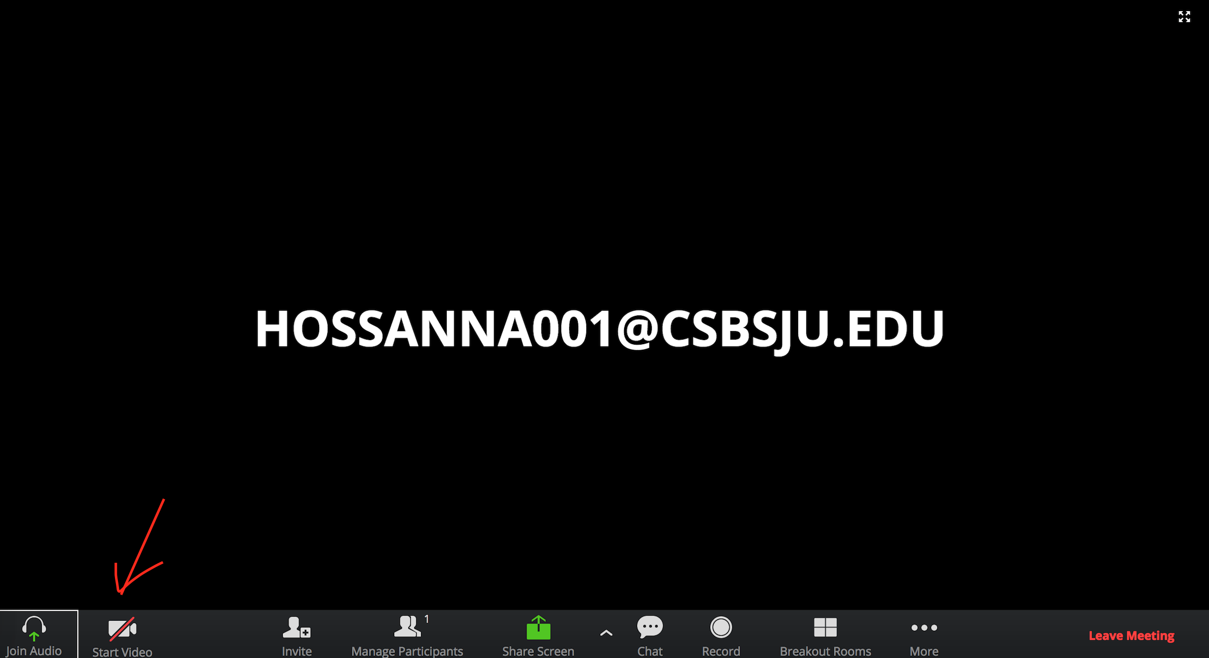

- You or the tutor have the ability to share your screen one at a time. The button to share can be found at the bottom of your screen highlighted in green. Both participants cannot share documents at the same time.
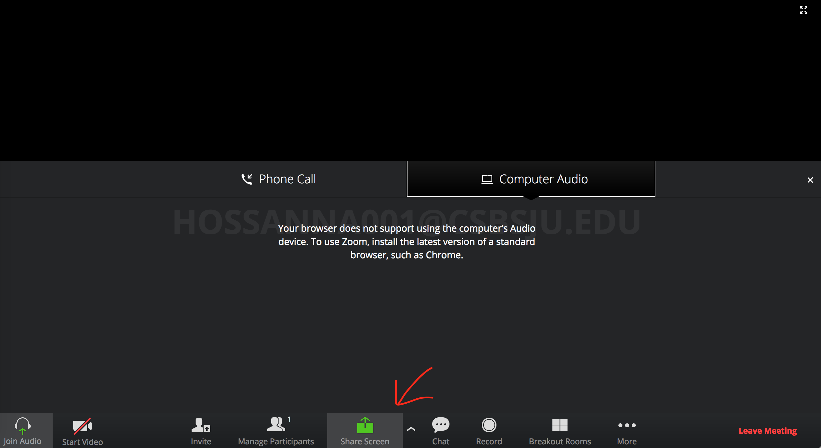
- The student should share your assignment with your tutor via Share Screen. You will have the option to share your entire screen or an application window.
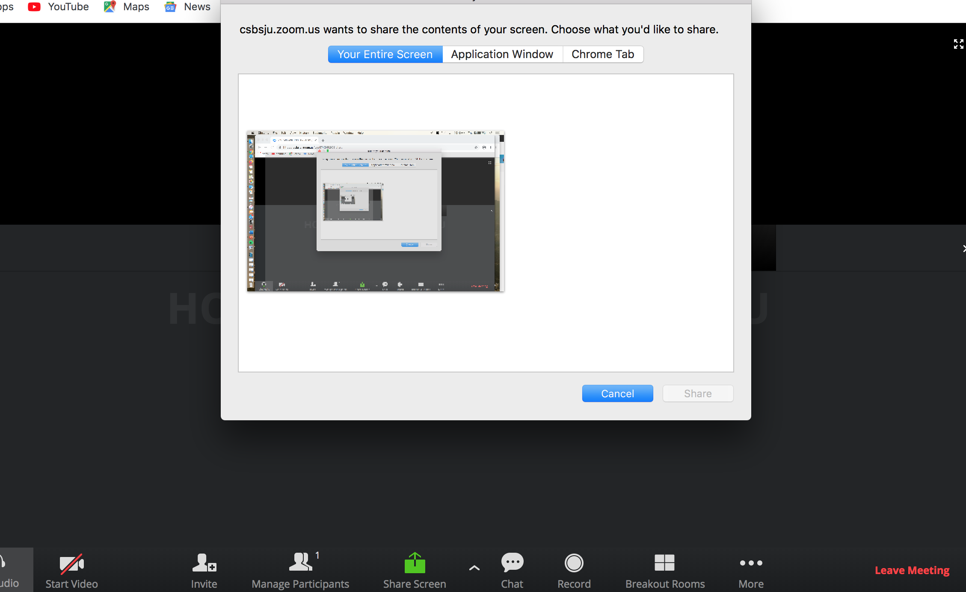

- Click the button to share an application window.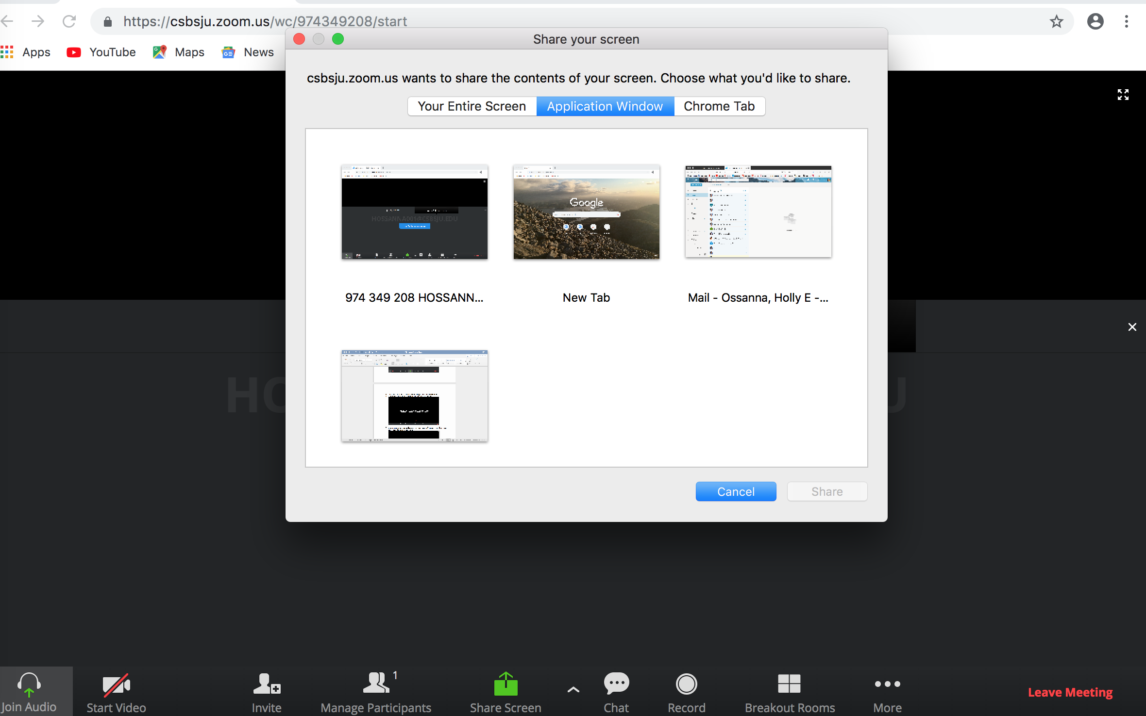
- Choose the application you wish to share with your tutor.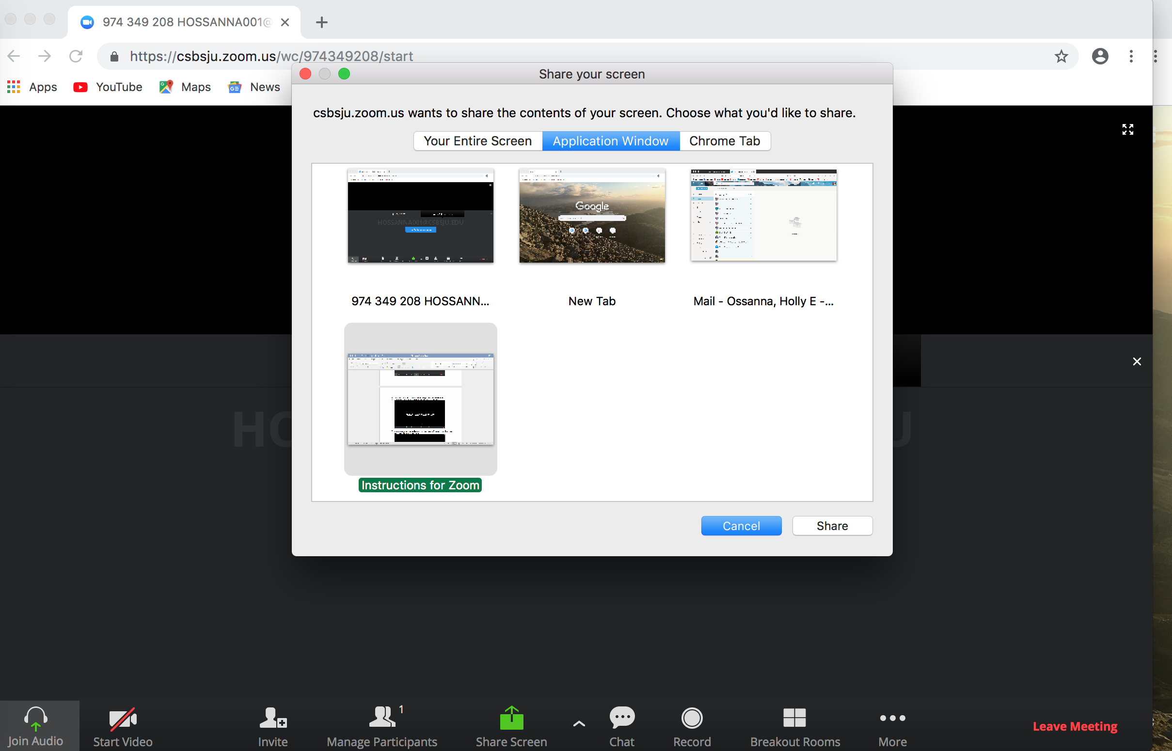

- If you wish to pause or stop sharing your screen click the pause button at the top of your screen.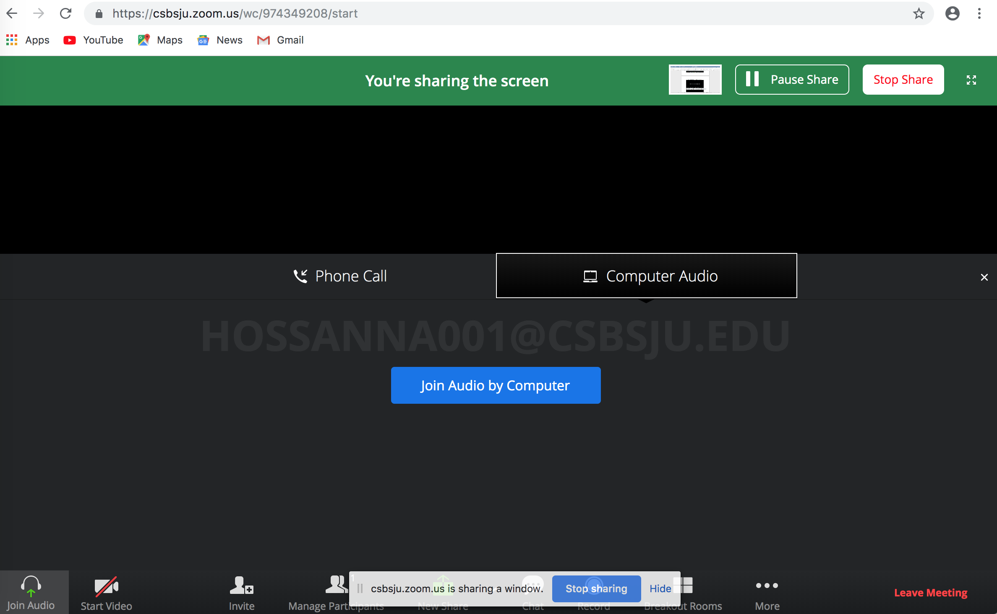

- If you cannot access audio or video, a ‘chat’ option is also available. 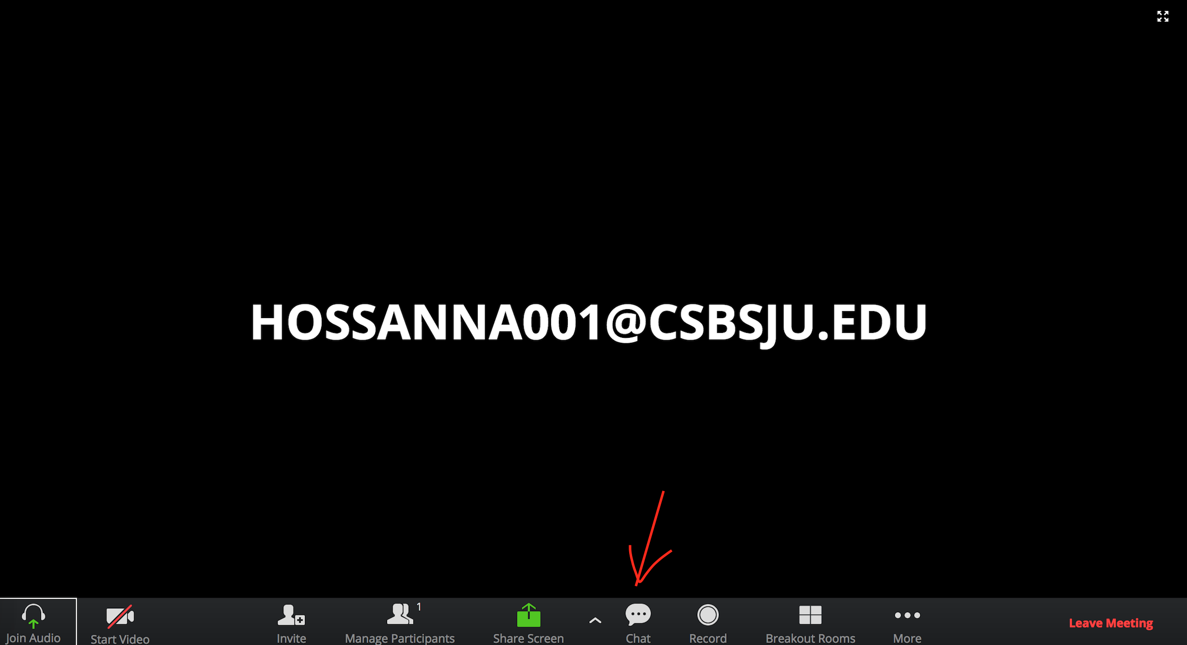

- Once the session has concluded you can push ‘leave meeting’, which is highlighted in red at the bottom righthand of your screen.
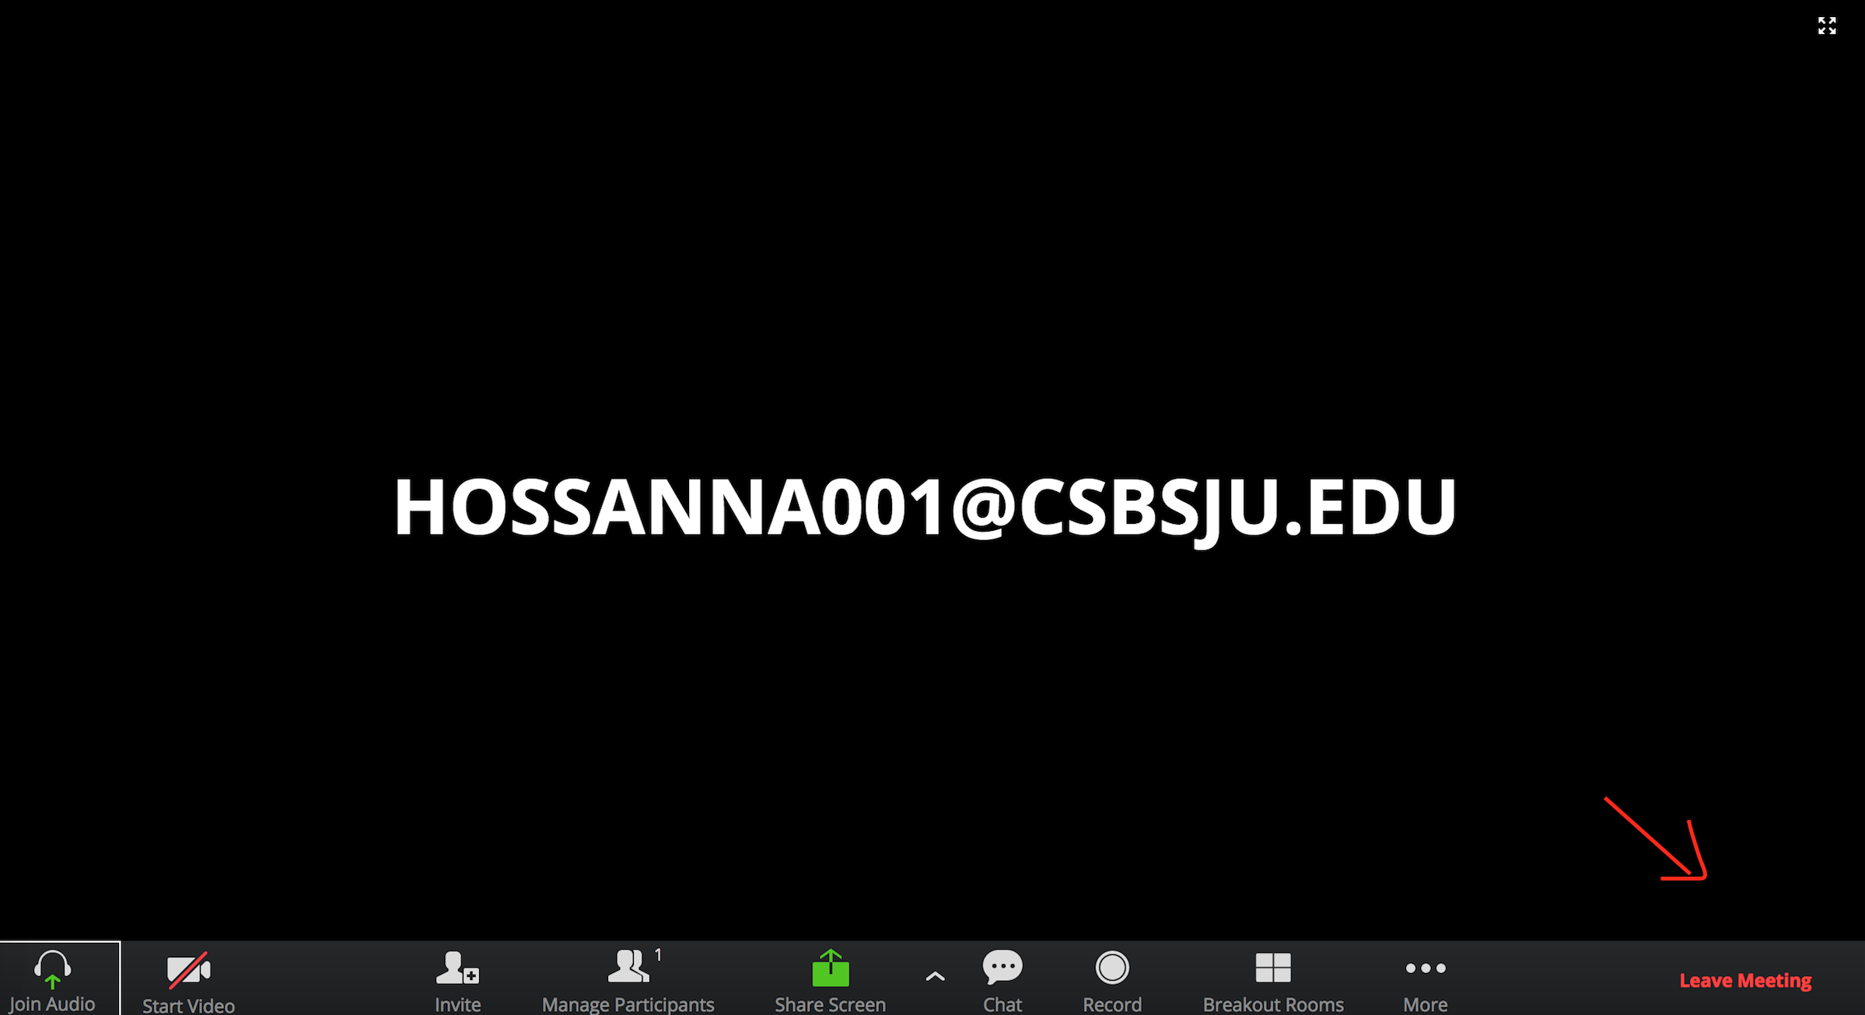

- Shortly after your appointment concludes, your tutor will notify your professor and you after your session with some brief notes on what was covered (unless otherwise requested).

Any questions? Please email writingcntr@csbsju.edu and/or Writing Center Director Kyhl Lyndgaard (klyndgaard@csbsju.edu).

