LEARNING TO LEARN
Tom Thole Study Center
Alcuin 371 @ SJU

You’ve been improving skills in all manner of activities all your life, perhaps with the help of a friend who edits your papers, a coach who pushes you to practice until you achieve just the right spin on a ball, or a mentor who challenges you to see how connections with others can create opportunities for the future. As you improved, you have had opportunities to “step up” to a higher level of skill and more advanced coaching, where more is asked of you. So, you improve, and then have another opportunity to step up. And the cycle continues. All along, you have been learning to learn.
The process works similarly in college-level learning. You have achieved skills that helped create the opportunity for you to be here, to elevate your learning, and to engage new information in more complex ways.
An understanding of the distinct levels/types of learning will help you navigate your academic work and will ultimately help you convey your capabilities to future employers.
Bloom’s Taxonomy, developed by Benjamin Bloom (a psychology professor and researcher at the University of Chicago) and his colleagues, classifies the cognitive levels of learning.

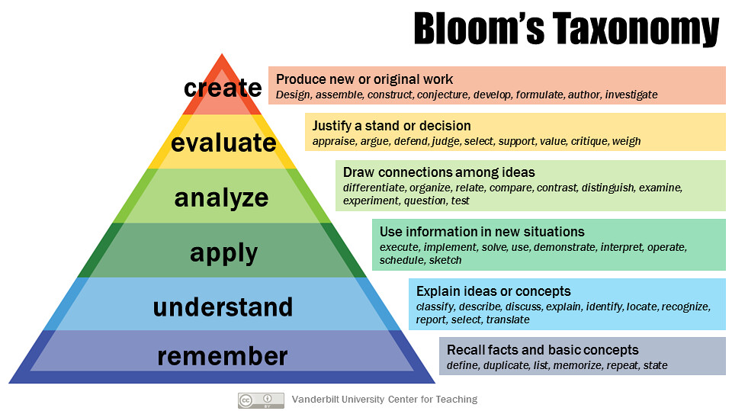

As you engage in reading, studying, assignments, papers, and exams for your classes, be aware of the levels of Bloom’s that you are using. When you see these verbs (apply, analyze, evaluate, etc.) in your assignments and learning goals for your course, refer to this information so you’ll know more about what is expected and how you are advancing in your learning skills.
See Strategies for Different Types of Learning for specific examples about how to make Bloom’s Taxonomy work for you.

