Updated on: February 2021

Navigate the Student View of The HIVE

- Dashboard – UPDATED Now Mobile Responsive!
- My Success Network
- Success Plans
- Upcoming
- Courses
- Request Help
- Messages

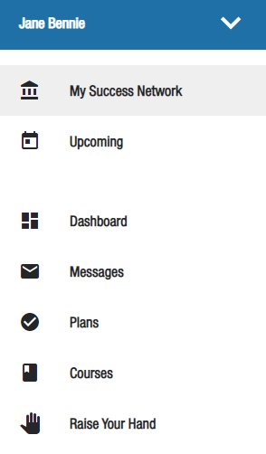
The details of what displays for students and what they can access in The HIVE include the following components: Navigation, Profile, Dashboard, Success Plans, My Success Network, Upcoming, Course, Request Help and Messages. If a user (faculty/staff member) has multiple roles, one of which is student, some of these components may display for them as well. Students with a Peer Leader Role in The HIVE like a Writing Center Tutor, FYX Peer Mentor, XPD CA and others have a staff role in addition to their student role and therefore their home page and menu may differ from other students. All student pages are now mobile responsive and will display well and adapt the view for PC, tablet, or phone.

Navigation

The student can use the side navigation menu to update their student profile or browse the available pages in the menu. The different pages or sections of The HIVE are referred to as channels.

Student Profile

Some of the student's information is automatically updated by the institution and cannot be edited. Students can select reminder settings from the Notifications tab as well as opt in and out of Text Messages sent via the HIVE. The use of texting by CSB/SJU administration will be limited and can only be done via approved message templates that include text messages for a particular communication chain. These text templates are set up by the System Administrator in part to keep texting to a minimum. All students will be opted in by default, they will receive a message that gives them the option to opt out. Students can come back to profile and opt in or out at any time. See Notifications for more.
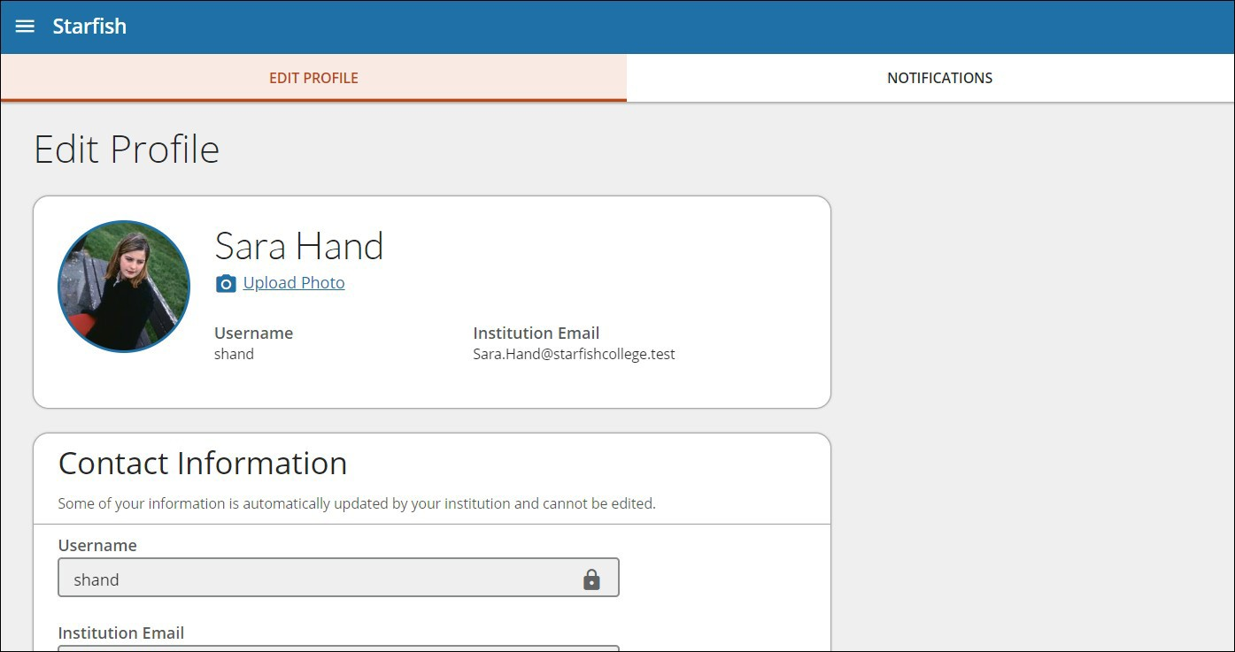

*NEW/Improved* - Student Mobile Responsive Dashboard

The student Dashboard channel will now display tiles for the student's Calendar, Notifications, High Fives, My Connections and My Services.
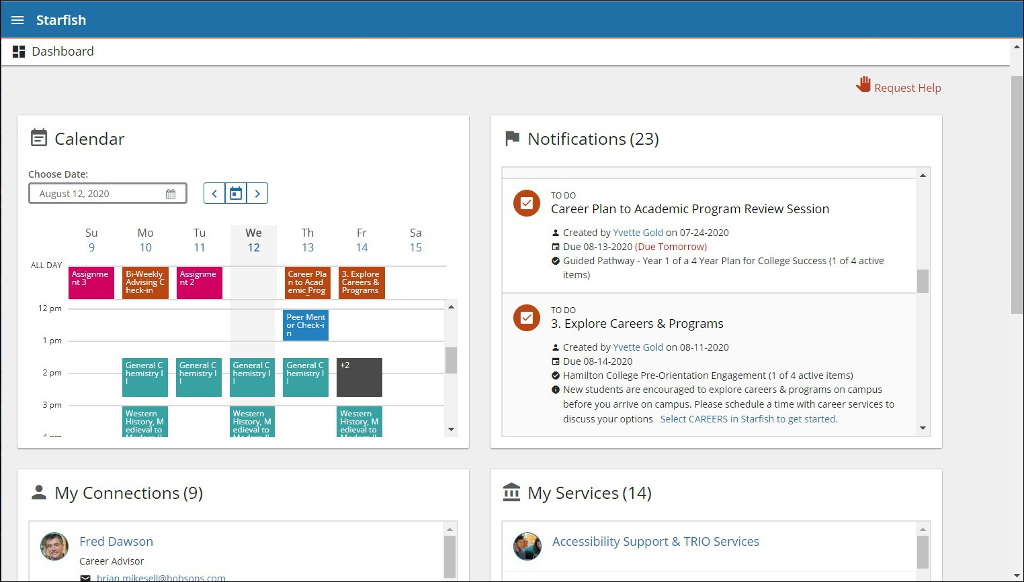

Dashboard Calendar Tile

The calendar tile displays the student's course schedule, appointments and group sessions scheduled using The HIVE and, in some instances, assignments imported from the LMS (Canvas). Additionally, tracking items with due dates (such as referrals or to-do items) display here. Students can: Click on the items that display in the ALL DAY row to display additional information.
Tip: Assignments that are due October 1 00:00 or October 1 23:59 will both display in the ALL DAY row on October 1.
Click on the date to display all activities for the day.

Click on a course section to display additional course information. Scheduling with related student services may also be available. If a service includes a waiting room for walk-in appointments, the student can see at a glance how many students are currently in line on the Wait List. Click on a +# (e.g., +3) to display additional information about all the items during a block of time.
Tip: Assignments that are due with a specific date and time such as October 1 09:00, display on the calendar during the hours of 8 - 9am.
View past or future weeks by choosing a date or using the left and right arrows next to the calendar icon. The calendar icon returns students to the current week.

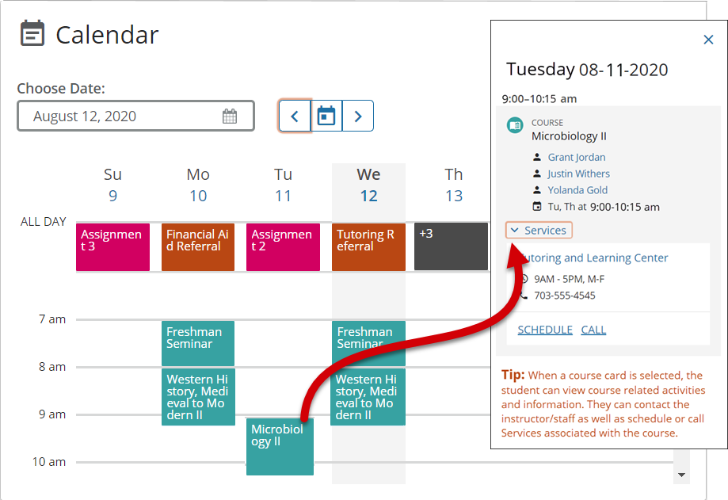

Dashboard Notifications Tile

The notifications tile displays all open tracking items. Notifications are ordered by due date. Any notifications without due dates display last and are ordered by creation date. If a student has a critical flag, the notification displays with a red bar and a Critical Flag label in red text.

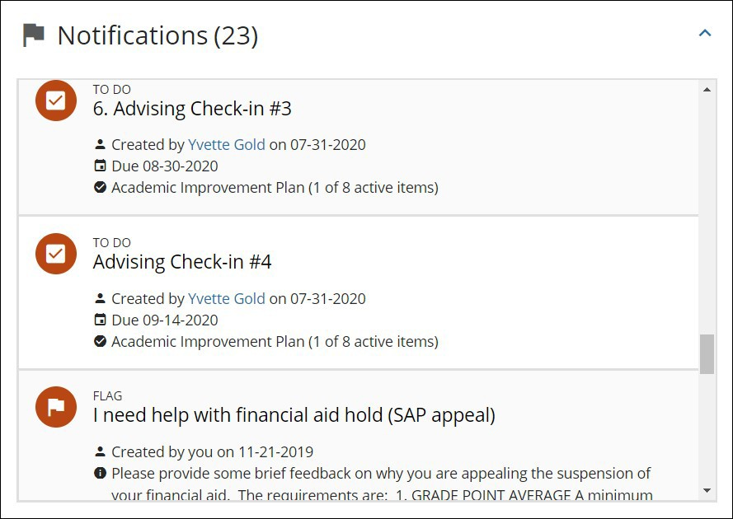

Dashboard My Connections Tile

The connections tile enables the student to schedule an appointment or contact faculty/staff from their success network.

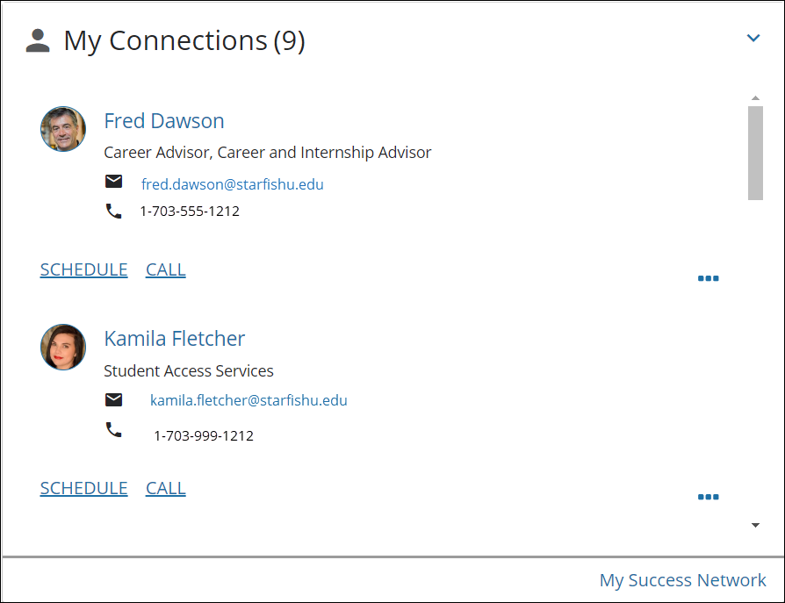

Dashboard My Services Tile

The services tile enables the student to schedule an appointment or contact services available CSB/SJU. If a service includes a waiting room for walk-in appointments, the student can see at a glance how many students are currently in line on the Wait List. The student can access the full list of services, including other services, using the My Success Network link at the bottom of the tile.
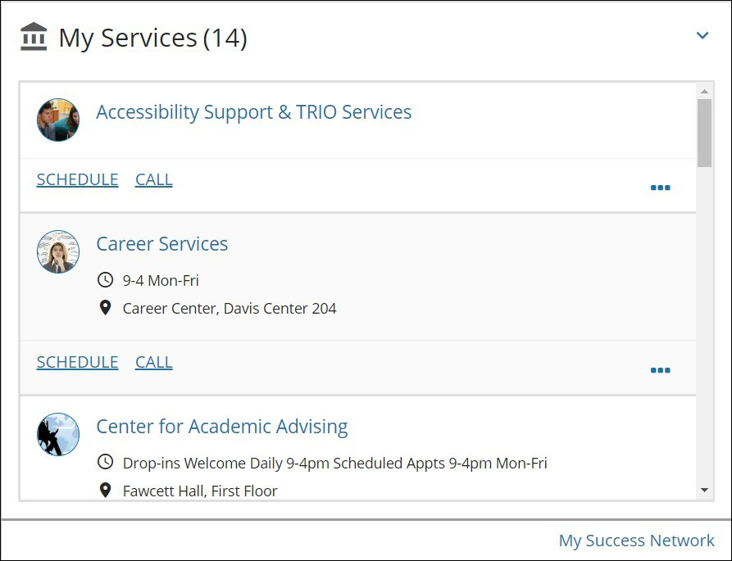

Dashboard High Fives Tile

The High Fives tile displays High Fives the student has received from their instructors, staff across campus or after visiting campus services. If a student has more than six active High Fives then this tile displays the six most recent High Fives.
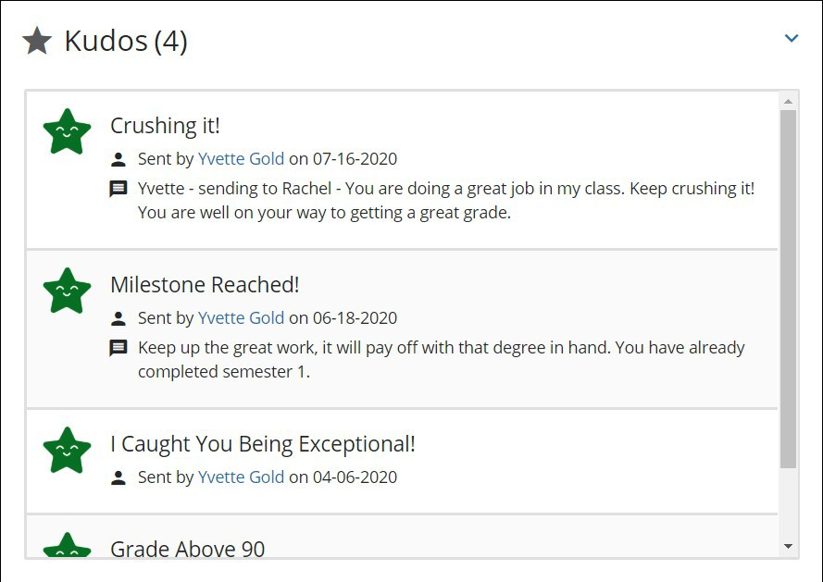
Dashboard Request Help

The request help icon enables the student to request help by raising Flags for themselves. (See Request Help below for more.)
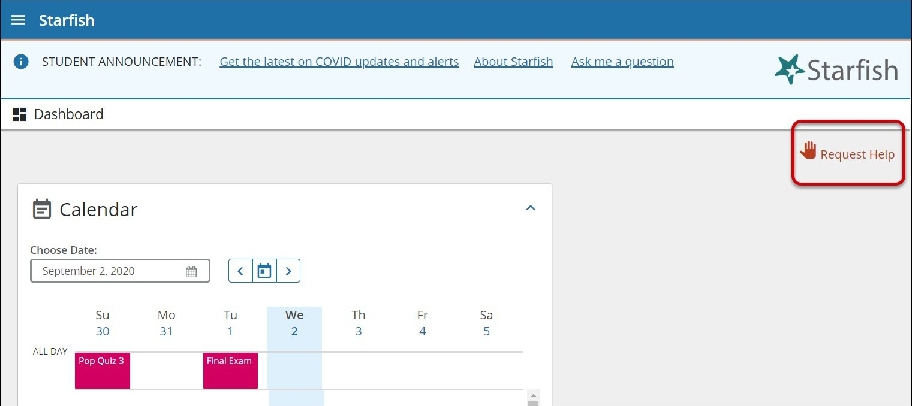
Upcoming

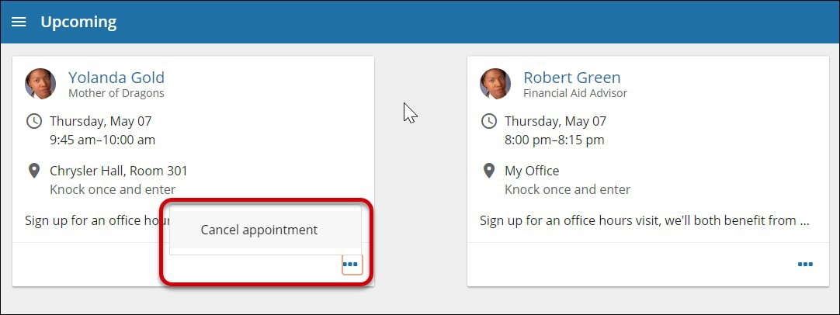
The Upcoming channel allows students to view or cancel upcoming scheduled appointments.
Courses

The Courses channel displays the courses in which the student is enrolled and provides contact and additional information for the instructor. The Courses channel defaults to the active term, however, the student can select the dropdown to choose a specific term when necessary. If the instructor has office hours for appointments the Schedule Appointment link displays. This listing may also include services to which the student has access that are related to the course/instructor, or they can use the Help icon to request help specifically for the course. Grades and Agenda tabs may display additional information if that data is available. On the Agenda tab, students can view their assignments.

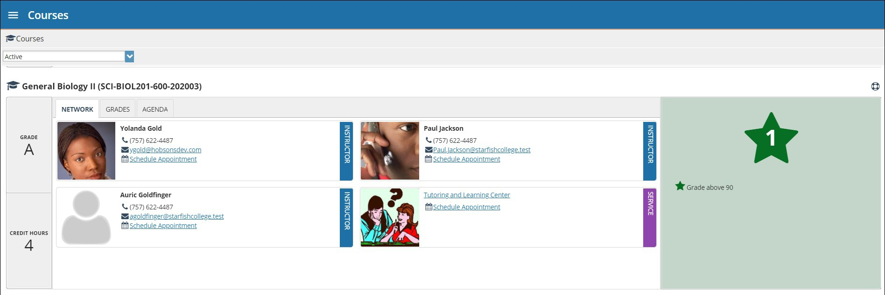

My Success Network

The My Success Network channel lists the people and resources that are available to assist students. For each person or service listed the student will find contact information, supporting websites, and, if online scheduling is enabled, a link to make an appointment.

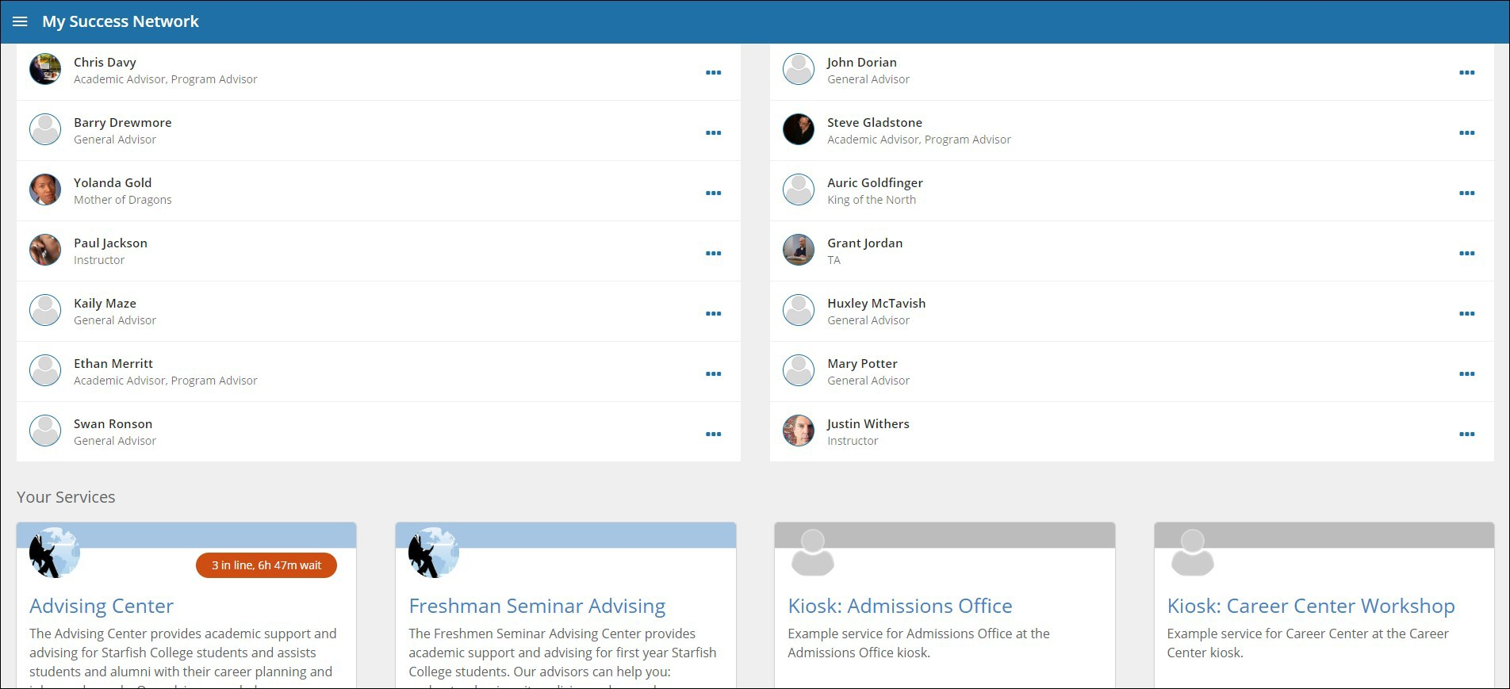
Messages

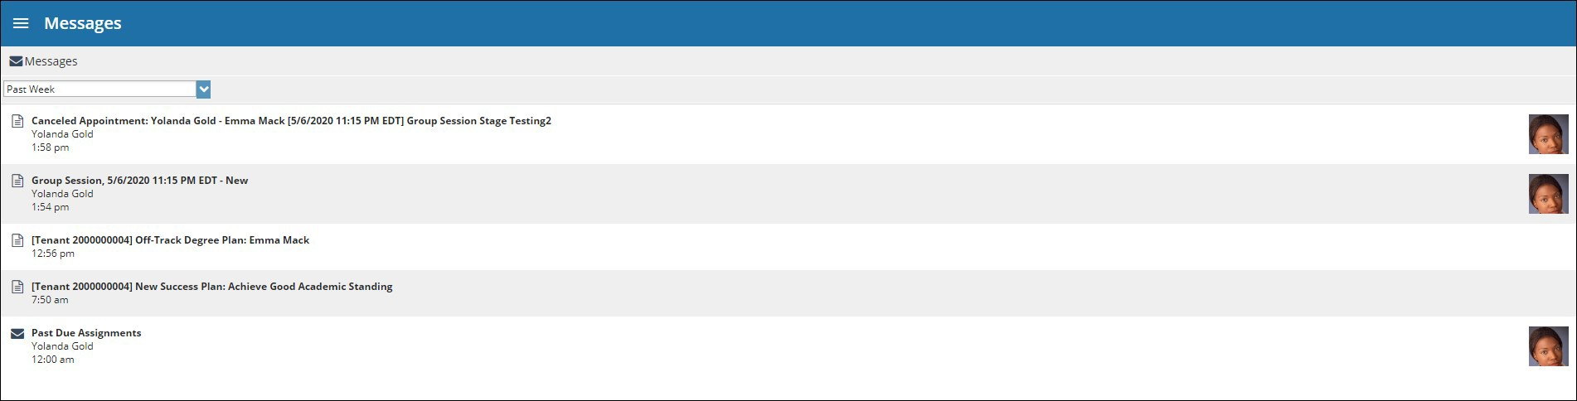
The Messages channel lists the messages sent to the student through The HIVE. Students can click on any message in the list to view the full contents of the message.

Request Help/Raise Your Hand

This channel provides access to online help resources for students and allows students to "raise their hand" to request assistance themselves.

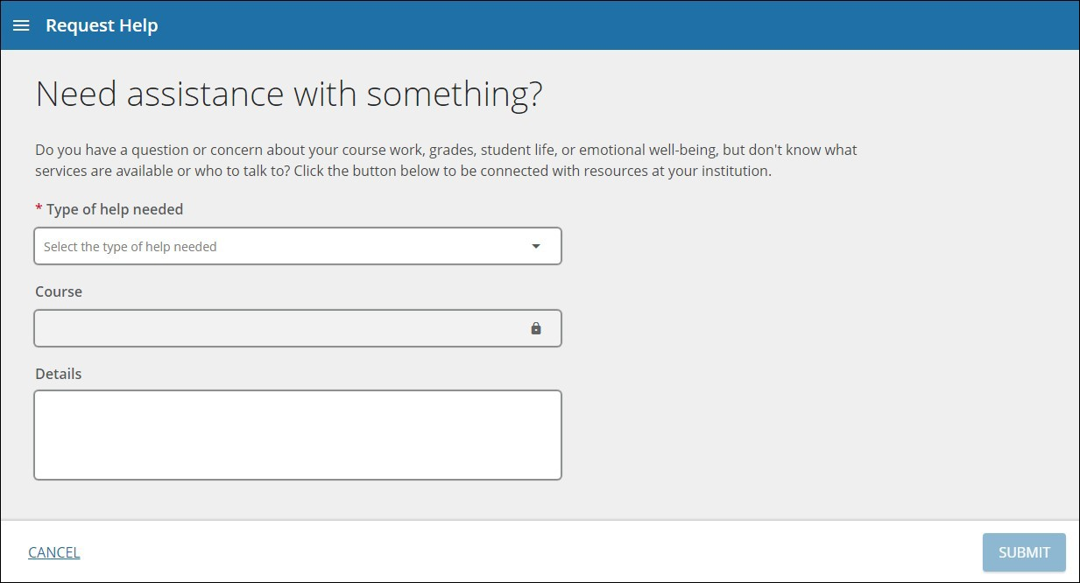
A general message to student confirming receipt of “Raise Your Hand” flag will be sent after a student submits an item/request help. Outreach will be done by appropriate corresponding offices regarding the students concerns. The message the student sends will be directed to the right offices based on the item they select. Staff in service areas should clear the flag as they are able to connect with and assist the student.

Examples of some CSB/SJU Raise Your Hand categories:
- Item Name: I have questions about my schedule.
- Item Name: I need help in a course. (This is directed to course instructor)
- Item Name: I need help with an issue outside the classroom.
- Item Name: I need help with online learning or technology.
- Item Name: I need help navigating my student account.
- Item Name: I have a question about Student Employment.
- Item Name: I need help with my student loans.
- Item Name: I need help with my Financial Aid.

Success Plans
Success plans help to organize process or actions that students need to take. Success plans may be created and assigned to a student and could include application processes, academic success plans, or to-do lists for different parts of your academic journey. If you are assigned a plan, be sure to follow up on any flags or referrals in the plan and complete the to-do items. As you complete the items in the plan staff members will update the tasks in the plan to reflect a change from “Open” to “Resolved”. When you have completed each task you will get a closure message confirming that you have fulfilled the steps in the plan!
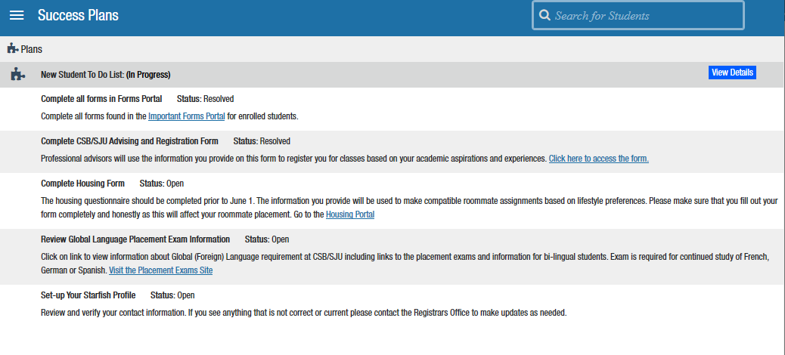

Intake

The HIVE Student Intake channel allows CSB/SJU to develop a customized questionnaire that students or staff can complete to allow students to let their support network start to get to know the student and their goals. The intake form can also be updated to reflect changes in the students' goals or circumstances throughout their time at the institution.

