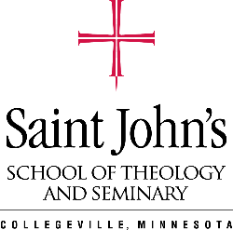
Saint John’s School of Theology and Seminary
Ministerial Residency Program
Position Description Template

[Name of Organization or Parish]
[Position Title]
Position Description
List the basic role of this position. In about 1-4 sentences, describe the basic functions of the position and how it relates to the broader organization.

Site Supervisor
Who the ministerial resident will report to and who will guide the student through their residency.

Principal Responsibilities
A list of responsibilities associated with this role and the frequency/amount of time these roles will occur. For example, if the resident must attend a particular council meeting, are these meetings monthly, bi-weekly?

Specifications and Qualifications
List the minimum qualifications that the resident must possess in order to perform the principal responsibilities of this role.

Residency Duration
Please list if this is a short-term position based ministry position, or a long-term position oriented residency; and how many hours the student is expected to work

Compensation
Please list the hourly rate for this position

Application Instructions
Please list any additional steps for applicants to apply for this position and contact person to apply. We have specific questions that applicants will answer, you are free to add onto that if you wish. You may have a specific process your employees follow.

If you are looking for a sample description of a particular type of position, please contact Bailey Walter at bkwalter@csbsju.edu

