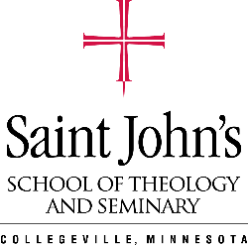
Saint John’s School of Theology and Seminary
Ministerial Residency Program
Application

Please fill out the following electronically and submit as a part of your application package.

Position Applying For:

Personal Information
Name:
Address:
Email:
Intended Degree:
First Enrollment Term:

Please provide the following information in two-to-four pages:
- Describe how you hope to use your theological education after graduation.
- List three experiences or qualities that you bring to this position and describe how you have used these in ministry or related areas.
- List and explain three things you would like to learn from this position.
- List three or four skills you bring to this position.

Note, there may be additional questions from the site supervisor added on to this list

