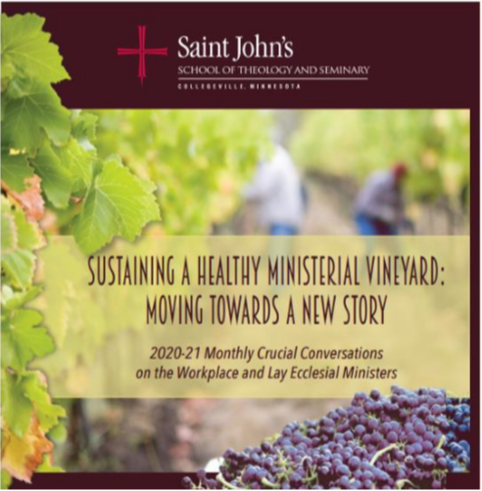

Advancing the National Will for a Healthy Ministerial Workplace
FIELD NOTES FROM THE VINEYARD
March 11, 2021
Breakout Room Facilitators
Barbara Sutton and Victor Klimoski
Prayer Presider
Brenda Kresky
Liturgy and Technology
Lori Dalhoff, Kyle Lechtenberg, Anisabel Palma Zamora Medina, Tim Welch

OVERVIEW
Over the past year our Crucial Conversations has set the stage for a substantial shift and expansion in mindset regarding moving towards a new story for the ministerial workplace. You are invited to help us think about the next BIG STEP on this journey. Our time together will look at those factors that contribute to a lack of engagement in the workplace, brainstorm the next desired situation we want to embrace in advancing the national will toward Sustaining a Healthy Ministerial Workplace.
OUR AGENDA
Welcome Towards a New Story Gathering Prayer Welcome and Description of Process
Breakout Rooms
- Clarifying Desired Outcome for Advancing the National Will for Sustaining a Healthy Ministerial Workplace
- Brainstorming Driving and Restraining Forces on the Desired Outcome
- Ranking and Prioritizing the Forces
- Suggest Strategies
Large Group Process
- Report #1 Driving Force and Strategies
- Report #1 Restraining Force and Strategies

TOWARDS A NEW STORY
We are convinced that sustaining healthy ministerial workplaces, build on covenant relationships and a commitment to justice, equips parishes for communion and mission. Healthy workplaces result when pastoral leadership teams actively cultivate trust, community, fairness, financial well-being, shared values, manageable workload, appreciation, and vocational commitment. Still inspired by the USCCB pastoral letter, Co-Workers in the Vineyard of the Lord (2005), we invite you on this journey to help foster healthy workplaces for all who minister in the name of Christ.

THE CONTEXT
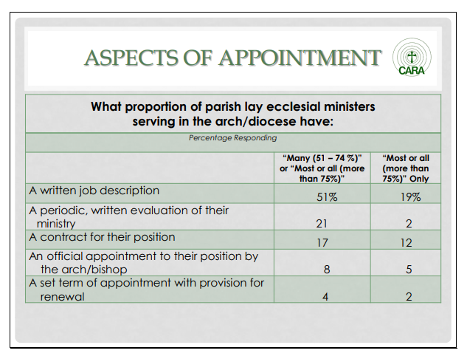
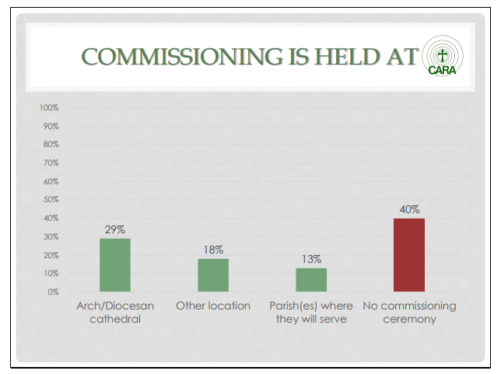
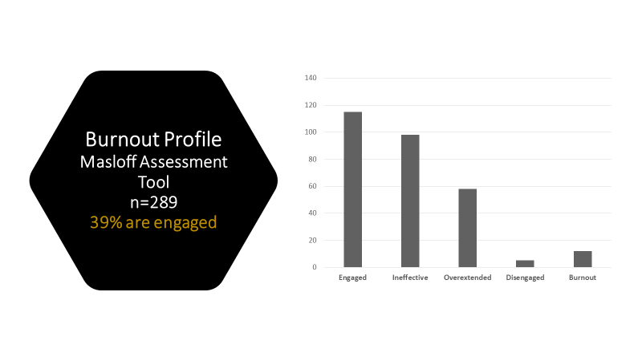
CRUCIAL CONVERSATIONS (August 2020 to March 2021)

Begin with the end in mind. Steven Covey
BREAKOUT ROOMS
Our Breakout Room tasks are twofold, the first is to provide input on the Desired Outcome or new big steps for this initiative. Your facilitator will lead the process.

Desired Situation for the next big step: 1) To promulgate the Ministerial Workplace Covenant Assessment and the Indicators for Sustaining a Healthy Ministerial Workplace through print and web resources. 2) In the next two years, pilot the Ministerial Workplace Covenant Assessment and the Indicators for Sustaining a Healthy Ministerial Workplace with at least five parishes and diocese who extend an invitation to learn more about the process. 3) To educate and collaborate with other national ministry organizations to advance a culture for a healthy ministerial workplace. 4) To find a way forward with forming and sustaining a healthy ministerial workplace that may include resources, organizational self-assessment, and a data base for Healthy Ministerial Workplaces.
For your reflection…..In what ways is this the next big step? Do you have suggestions or other ways to advance the national will for a Healthy Ministerial Workplace? What would you like to add to this or invite others to reconsider for the next big step?

The second task is to brainstorm the forces for and against the current state of sustaining a healthy ministerial workplace. Then you will prioritize the top three driving and restraining forces. And finally, you will suggest strategies for the #1 Driving and Restraining Forces.
As you brainstorm, it is important to consider three types of forces that may be generated: (A) forces that can be controlled by the group, (B) forces that the group can influence but not completely control, and (C) forces over which the group has no control. Lead a discussion to help the group identify these. It will be helpful to focus on those forces that are in items A and B.

How to Strengthen | A B C | Driving Forces | Restraining Forces | A  B  C | How to Weaken

SELF-ASSESSMENT OF INDICATORS FOR A HEALTHY MINISTERIAL WORKPLACE (N=22)
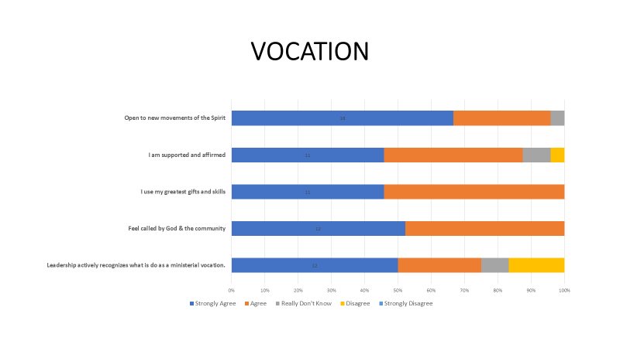
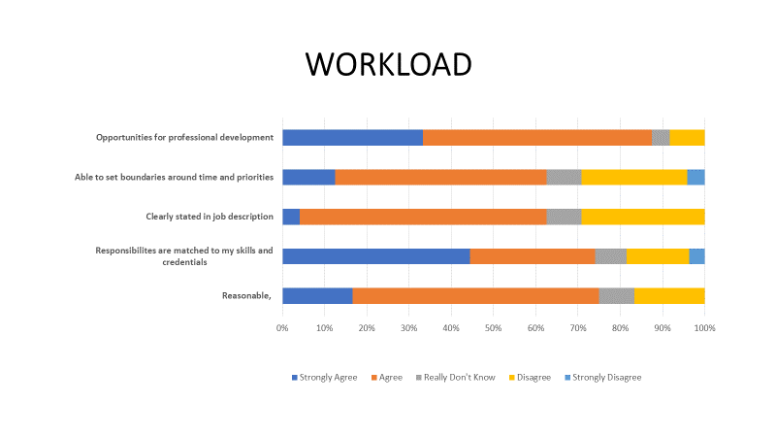

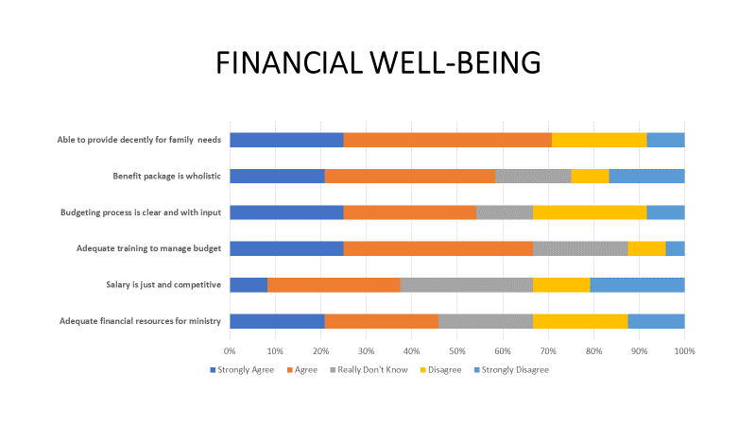

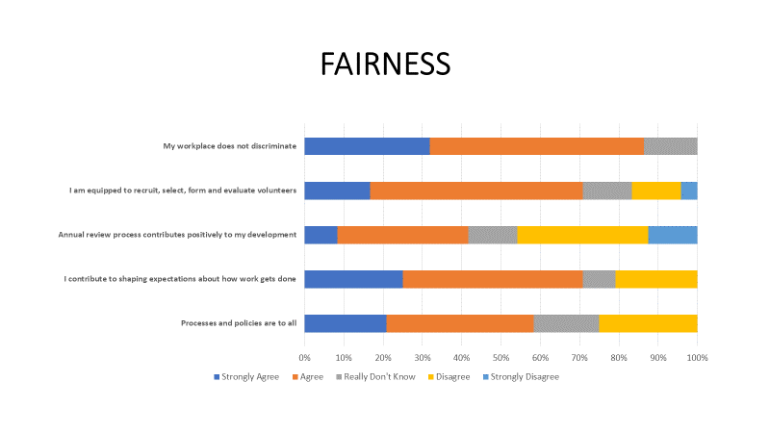

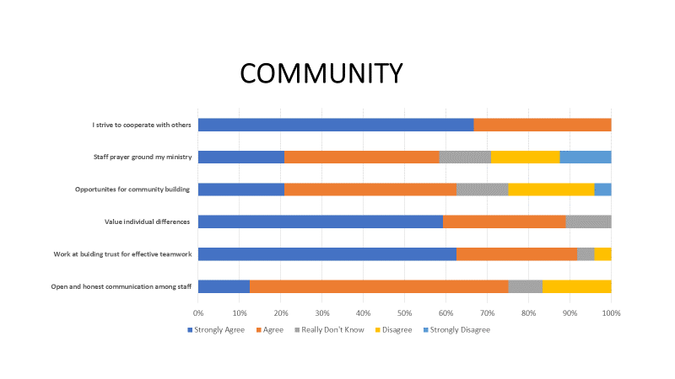
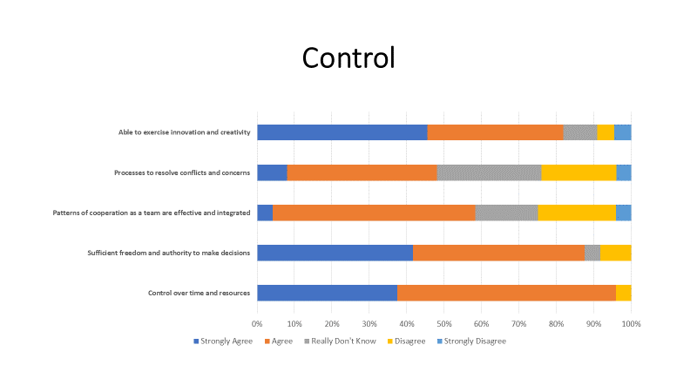

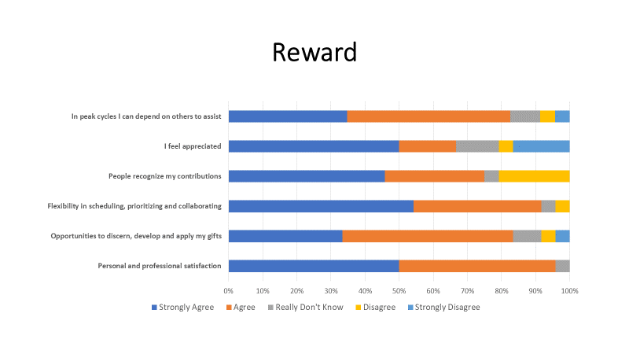

A Healthy Ministerial Workplace Index
This assessment tool is a resource for people as they reflect on the health of their workplace using eight key elements. While there may be other elements, these eight represent key aspects of organizational life that impact people’s attitudes, satisfaction, and engagement. For each element, there are a set of statements about indicators known to positively affect that element. There may be other indicators, but we have determined that these play a key role in workplace health.
The Index is for individual use and is a companion piece to the Healthy Workplace Covenant Assessment. The latter is for a workplace group to use as a reflection guide in examining the health of their workplace and, more importantly, designing specific, concrete actions to improve and strengthen the workplace.
In completing the Index, people should select the assessment category that most accurately reflects their experience. Avoid the extremes of rating everything high because “that’s what good people do” or rating everything low because you are annoyed that more is not being done and being done better.
The results can be grafted as suggested on the last page. This provides insight into how the results might be impacting your life and performance as a minister in the workplace. The profile plots results on a continuum of engaged and disengaged. Higher scores suggest a level of engagement in the workplace suggesting health. Lower scores indicate elements of the workplace that nudge you towards disengagement. Disengagement that is ignored contributes to eventual burnout.
Neither the Index or the summary graph are predicative. They are designed to provide a more structured way for thinking about workplace health and to encourage reflection.

For each of the following indicators, select one of the following response categories that best reflects your judgment based on your experience and perceptions:
5  STRONGLY AGREE | 4  AGREE | 3  REALLY DON’T KNOW | 2  DISAGREE | 1  STRONGLY DISAGREE

5  STRONGLY AGREE | 4  AGREE | 3  REALLY DON’T KNOW | 2  DISAGREE | 1  STRONGLY DISAGREE

VOCATION
1. Workplace leadership actively recognizes what I do as a ministerial vocation. | 5 | 4 | 3 | 2 | 1
2. I continue to feel called by God & the comm- unity to the work with which I am entrusted. | 5 | 4 | 3 | 2 | 1
3. My position calls me to use my greatest gifts and skills to serve the People of God. | 5 | 4 | 3 | 2 | 1
4. My workplace & those I serve support & and affirm me as a person in my ministerial vocation. | 5 | 4 | 3 | 2 | 1
5. I am open to new movements of the Spirit in my vocation. | 5 | 4 | 3 | 2 | 1

VALUES
1. The values that guide my practice of ministry align with the stated values we profess in our workplace | 5 | 4 | 3 | 2 | 1
2. I integrate the stated values of our workplace in my daily ministry. | 5 | 4 | 3 | 2 | 1
3. Scripture and theology form and inform the way I minister. | 5 | 4 | 3 | 2 | 1
4. I am able to receive feedback when the way I minister does not align with values. | 5 | 4 | 3 | 2 | 1
5. I feel safe giving feedback when actions or decisions do not align with values. | 5 | 4 | 3 | 2 | 1

WORKLOAD
1. My workload is reasonable, enabling me to meet the expectations for my position. | 5 | 4 | 3 | 2 | 1
2. My responsibilities in my ministry are commensurate with my skills and credentials. | 5 | 4 | 3 | 2 | 1
3. My workload is outlined in a clearly stated job/role description. | 5 | 4 | 3 | 2 | 1
4. My workload enables me to set appropriate boundaries around my time and priorities. | 5 | 4 | 3 | 2 | 1
5. I have sufficient opportunities annually, for personal and professional development that my ministry site actively supports. | 5 | 4 | 3 | 2 | 1

5  STRONGLY AGREE | 4  AGREE | 3  REALLY DON’T KNOW | 2  DISAGREE | 1  STRONGLY DISAGREE

FINANCIAL WELL-BEING
1. I have adequate financial resources to fulfill the vision of the ministry. | 5 | 4 | 3 | 2 | 1
2. I am aware the salary for my position is a just and competitive salary. | 5 | 4 | 3 | 2 | 1
3. I have adequate training to manage by budgetary responsibilities for my ministry. | 5 | 4 | 3 | 2 | 1
4. The budgeting process is clear and provides opportunities for input. | 5 | 4 | 3 | 2 | 1
5. My benefits package is wholistic, including provisions for ongoing professional and spiritual growth. | 5 | 4 | 3 | 2 | 1
6. I am able to provide decently for my own needs and those of their family. | 5 | 4 | 3 | 2 | 1

FAIRNESS
1. I find that our processes and policies are fair to all employees and volunteers. | 5 | 4 | 3 | 2 | 1
2. I contribute to shaping expectations and assumptions about how work gets done. | 5 | 4 | 3 | 2 | 1
3. The annual review process that contribute positively to my ongoing development. | 5 | 4 | 3 | 2 | 1
4. I am equipped to for recruit, select, form and evaluate volunteers. | 5 | 4 | 3 | 2 | 1
5. I believe that the my workplace operates in a way that does not discriminate in regards to race, ethnicity, national origin, sexuality, disability and language preferences. | 5 | 4 | 3 | 2 | 1

COMMUNITY
1. Open and honest communication among the staff supports and encourages me. | 5 | 4 | 3 | 2 | 1
2. I work at building trust with my colleagues for effective teamwork. | 5 | 4 | 3 | 2 | 1
3. I value individual differences in the work-place & take action to make all feel welcome and accepted. | 5 | 4 | 3 | 2 | 1
4. My workplace provides opportunities for community building that supports collaboration and a positive spirit among us. | 5 | 4 | 3 | 2 | 1
5. I find our regular opportunities as staff for prayer and faith sharing ground my ministry. | 5 | 4 | 3 | 2 | 1
6. I strive to cooperate with others to create and sustain a healthy workplace. | 5 | 4 | 3 | 2 | 1
5  STRONGLY AGREE | 4  AGREE | 3  REALLY DON’T KNOW | 2  DISAGREE | 1  STRONGLY DISAGREE

CONTROL
1. I generally have adequate control over my time & resources to accomplish what expected. | 5 | 4 | 3 | 2 | 1
2. I have sufficient freedom and authority to make decisions based on the responsibilities of my job description. | 5 | 4 | 3 | 2 | 1
3. I think our patterns of cooperation as a team are effective and integrated. | 5 | 4 | 3 | 2 | 1
4. I am able to use processes in place to resolve conflicts and concerns. | 5 | 4 | 3 | 2 | 1
5. I have enough discretion in my work to exercise innovation and creativity in the face of changes that are emerging in ministry. | 5 | 4 | 3 | 2 | 1

REWARD
1. My ministry offers me a sense of personal and professional satisfaction. | 5 | 4 | 3 | 2 | 1
2. I am given opportunities to discern how to develop and apply my gifts in new, life-giving ways. | 5 | 4 | 3 | 2 | 1
3. Due to the complexity of my positions I have flexibility in scheduling, prioritizing assignments, and in collaborating with others. | 5 | 4 | 3 | 2 | 1
4. My supervisor and colleagues recognize my contributions to our common work. | 5 | 4 | 3 | 2 | 1
5. I feel appreciated. | 5 | 4 | 3 | 2 | 1
6. In peak cycles I can depend on others to assist. | 5 | 4 | 3 | 2 | 1

HEALTHY MINISTERIAL WORKPLACE: MAPING MY ASSESMENT AND ITS IMPACT
- To complete a graph of your results, total up the scores for each of the elements.
- Then place an X along the continuum to locate your score for that element.
- Finally, connect the X’s.
- Reflect on the questions that follow the graph
30 25 20 15 10 5 0
ENGAGED DISENGAGED
VOCATION

VALUES

COMMUNITY

REWARD

WORKLOAD

CONTROL

FAIRNESS

FINANCIAL WELL-BEING

- As you look at the overall pattern of your responses, which of the elements account for your engagement and what elements account for your disengagement?
- How might those elements that account for your engagement enable you to address element that lead to your disengagement?
- As you consider this profile, what are the strengths you bring to your workplace that contribute to greater engagement by all members?
- What three actions at the organizational level would help address elements affecting your disengagement.
Covenant for A Healthy Ministerial Workplace
A GUIDE FOR REFLECTIVE ASSESSMENT & PLANNING

How good and how pleasant it is, when brothers and sisters
dwell together as one!
Psalm 133:1

Statement of Workplace Covenant

A vocation to pastoral ministry is a call to advance the mission of the Gospel. The work we share finds expression in evangelization and catechesis, worship, pastoral care, outreach, formation, community building, stewardship, and leadership. We measure our success by growth in knowledge of God, co-responsibility for the Reign of God, and spirit of hope we cultivate in those to whom we minister and in ourselves. Ours is collaborative work, as ordained and lay ecclesial ministers. We form a community of ministerial leaders bound together by a commitment to Christ, his Gospel, and the care of God’s people. We will risk being transformed. We recognize that creating a healthy ministerial workplace is a responsibility each of us shares. In fulfilling that responsibility, we commit ourselves to the following principles:

1. We share a conviction that the Sacraments of Initiation form the common basis for our shared participation in the threefold ministry of Christ who is priest, prophet and king. We also acknowledge the complementarity of our distinct vocations as ordained and lay ecclesial ministers.

2  Yes, this describes us most of the time. | 1  This describes us a little. | 0  This does not describe us  and needs development.
What are some promising practices for this?

2. We gather for prayer, community and learning, knowing that the inspiration of the Scriptures and theological reflection on our ministerial practice ground us in sustaining right relationships and a healthy ministerial workplace.

2  Yes, this describes us most of the time. | 1  This describes us a little. | 0  This does not describe us  and needs development.
What are some of the promising practices for this?

3. Our mission and vision provide the values we seek to embody in every aspect of our work and that those shared values are a primary source of mutual good as we evaluate our ministerial leadership.

2  Yes, this describes us most of the time. | 1  This describes us a little. | 0  This does not describe us  and needs development.
What are some of the promising practices for this?

4. We strive to deepen the human competencies needed for effective teamwork and ministerial leadership. These include skills for strong interpersonal communication, intercultural competence, decision-making, management of conflict, ways to process difficult issues, and sustained collaboration across our designated positions.

2  Yes, this describes us most of the time. | 1  This describes us a little. | 0  This does not describe us  and needs development.
What are some of the promising practices for this?

5. We mutually define a manageable workload that provides the opportunity to serve the needs of the community through one’s designated ministry as well as one’s charisms and deep passions, to pursue career objectives, and to develop professionally.

2  Yes, this describes us most of the time. | 1  This describes us a little. | 0  This does not describe us  and needs development.
What are some of the promising practices for this?

6. We have in place a regular system of evaluation that provides insight into our work performance, raising up our accomplishments and finding resources and ways to address areas of needed growth.

2  Yes, this describes us most of the time. | 1  This describes us a little. | 0  This does not describe us  and needs development.
What are some of the promising practices for this?

7. To be in right relationship with all employees and volunteers, we practice being open to receiving and giving skilled and compassionate feedback.

2  Yes, this describes us most of the time. | 1  This describes us a little. | 0  This does not describe us  and needs development.
What are some of the promising practices for this?

8. We interact out of a shared understanding that the quality and effectiveness of our professional relationships have significant impact on those to whom and with whom we minister.

2  Yes, this describes us most of the time. | 1  This describes us a little. | 0  This does not describe us  and needs development.
What are some of the promising practices for this?

9. We contribute to developing and sustaining a healthy workplace by individual and team on-going education, ministerial formation, and the cultivation of imagination and creativity in whatever forms they might take.

2  Yes, this describes us most of the time. | 1  This describes us a little. | 0  This does not describe us  and needs development.
What are some of the promising practices for this?

10. We work at creating inclusive communities in which we cultivate respect for diversity of cultural traditions, languages, theological visions, devotional and spiritual practices.

2  Yes, this describes us most of the time. | 1  This describes us a little. | 0  This does not describe us  and needs development.
What are some of the promising practices for this?

11. We provide for the just and financial well-being of all employees in a fair and transparent manner.

2  Yes, this describes us most of the time. | 1  This describes us a little. | 0  This does not describe us  and needs development.
What are some of the promising practices for this?

12. We abide in the covenant through the principle of subsidiarity, when those closest to a problem or pastoral concern will be consulted for deeper understanding.

2  Yes, this describes us most of the time. | 1  This describes us a little. | 0  This does not describe us  and needs development.
What are some of the promising practices for this?

