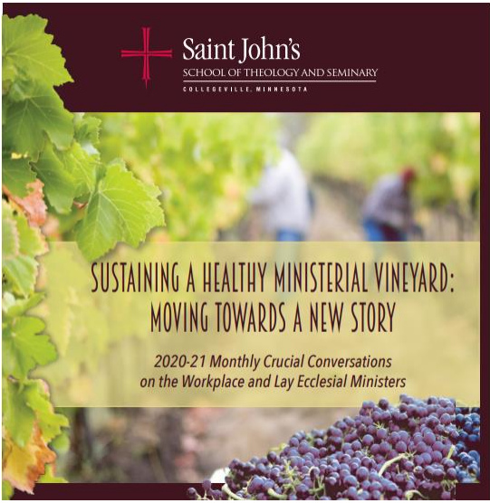

CRUCIAL CONVERSATIONS
Thursday, January 14, 2020
2:00 pm to 3:30 pm

ELEMENTS OF THE MINISTERIAL WORKPLACE
Kristi Bivens ~ Vocation
Robert Choiniere ~ Values
Timothy Johnston ~ Fairness
Bridget Klawitter ~ Control
Doric Law ~ Community
Kyle Lechtenberg ~ Rewards
Yaret Macedo ~ Workload
Jim Wahl ~ Financial Well-being

FIELD NOTES
This Crucial Conversation engages your pastoral experience and establishes a theological framework for the ministerial workplace. The workshops have been assigned by the preference you chose at registration. Please come ready and prepared to engage this Crucial Conversation by reading the texts that the writers have developed.

Workshop Purpose:
Each workshop explores an element of a healthy ministerial workplace under the leadership of a pastoral minister who has spent the past two years thinking, discussing, and studying the element. Their work grounds the conversation as we continue to explore the theological vision at the heart of healthy ministerial workplaces.
As you read the narrative anchoring your session, pay attention to ways in which it reflects your experience and ways your experience has been different. Our stories can be great teachers. For the workshop leaders, their narratives have been significant in their approach to the element assigned to them.
As you read the theological reflection for your workshop, consider the following:
- How does the facilitator’s theological exploration of this element resonate with your own experience and reflection?
- How might you build on or clarify points made by the facilitator that might enrich our understanding of the theological convictions at the heart of this element?

Workshop Outcomes
- To deepen the theological grounding for each workplace element
- To enrich the list of best practices for moving the element from theory to action

Workshop Norms
Good conversations depend on embracing some basic guidelines that create an environment in which people build on each other’s ideas. We ask that as you participate in your workshop, you keep the following in mind.
- BE PRESENT (focus on what is happening in the room, minimize distractions)

- PRACTICE HOSPITALITY (make space for people to feel welcome into the discussion especially when they might have an alternate point of view)

- LISTEN/SPEAK (listen heartfully, intent on hearing what someone is really saying; contribute your point of view and ideas even if they don’t seem quite “perfect”)

- BE CURIOUS (be curious about why someone has offered a point of view or idea, what they might be able to teach you)

- TRUST THE SPIRIT (the work we do is for the greater good and finds its origins and goal in the conviction that God blesses work undertaken confident in God’s abiding presence)

NOTES:

