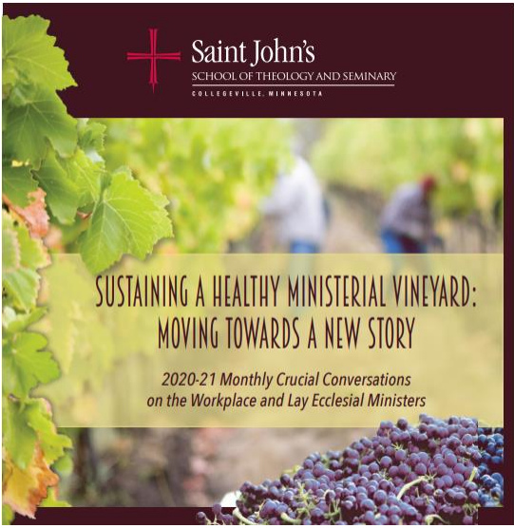

CRUCIAL CONVERSATIONS
Thursday, December 10, 2020
2:00 pm to 3:30 pm

ELEMENTS OF THE MINISTERIAL WORKPLACE
Kristi Bivens (Vocation) is the associate director of lay leadership formation for the Diocese of St. Cloud. She has a degree in Elementary Education from the College of St. Benedict in Minnesota. Prior to working for the Diocese of St. Cloud, Kristi taught at two Catholic elementary schools for eight years, took a break to earn a Master of Divinity degree from Saint John’s School of Theology and Seminary, and then spent 10 years as pastoral associate for two parishes in rural western Minnesota.

Robert Choiniere, D.Min (Values) is currently the Director of Adult Faith Formation at St. Francis Xavier parish in Manhattan and a Professor of Theology at Fordham University. He has served as a diocesan lay minister in the Diocese of Wheeling-Charleston, the Archdiocese of Philadelphia and as the Director of Pastoral Planning in the Diocese of Brooklyn from 2005-2014. Bob is also the former chair of the Conference of Pastoral Planning and Council Development. He received his Doctor of Ministry from Fordham University in 2018. Bob also holds an MA in Pastoral Ministry from Boston College and a BA in Theology and Theatre from DeSales University. Bob is a founding member and Managing Director of Stages on the Sound, Inc., a NYC based theatre company providing arts education programs to over 16,000 students each year.

Timothy Johnston (Fairness) serves as Editor and Liturgical Training Consultant for Liturgy Training Publications. He has a degree in music education from Quincy University in Illinois, an MA in liturgical studies from St. John’s University, Collegeville, Minnesota, and an MA in Christian Doctrine from Marquette University, Milwaukee, Wisconsin. He has served as the director of liturgical programs at Marquette University, director of the Office of Liturgy for the dioceses of Salt Lake City and St. Cloud. Timothy is co-author of Guide for Celebrating Infant Baptism (LTP, 2018), Disciples Making Disciples: Print and Digital Resources for Forming the Assembly (LTP, 2017), and Pocket Prayers for Times of Trouble (Twenty-Third, 2014).

Bridget Klawitter, PhD (Control) is currently the Pastoral Associate at St. Leonard Catholic Parish & School in Muskego WI. She has a wide range of responsibilities: assisting the pastor with the pastoral care of the parish including visiting the sick and home bound, and funeral planning and grief support. She also coordinates adult formation, adult sacramental preparation, and oversees multiple parish committees. Bridget worked in healthcare for over 30 years, primarily for Catholic organizations, and in 2008 left to work in parish ministry. She has graduate degrees in education and in lay ministry and is the first nationally certified lay ecclesial minister in the Archdiocese of Milwaukee.

Doric Law, M.Div. (Community) lives in Plymouth, MN. She has served in health care, parish and campus ministry. Currently she serves as Chaplain at Catholic Eldercare. She is a graduate of Saint John’s School of Theology and Seminary and holds a Master in Education Administration and Policies from the University of Minnesota. She completed her Chaplain Residency at Park Nicolet Methodist Hospital. She also serves on the Archdiocese of Saint Paul & Minneapolis Diocesan Planning Commission.
Kyle Lechtenberg (Rewards) was baptized at St. Mary's Catholic Church in Strawberry Point and grew up in that area of northeastern Iowa. In 2016, he and his wife, Kara Ullestad, were married at Capitol Hill Lutheran Church in Des Moines. They welcomed their daughter, Sage Elise, in August 2017. Kyle joined Our Lady's Immaculate Heart Parish in the summer of 2015 as a parishioner and as Director of Music and Liturgy. Kyle enjoys serving God through resourcing the nearly 600 music and liturgical ministers who help lead the whole assembly's worship of God. He directs the Magnificat Choir and Trinity Ensemble, and supports directors of the Cherubim, Youth, and Regina Coeli Choirs along with the other liturgical ministries. In previous positions, Kyle has served in diocesan and parish ministries in Des Moines and Dubuque, as well as a public school vocal music teacher for grades 7-12 in Independence, Iowa. His undergraduate music degree is from the University of Northern Iowa, and his Master of Theological Studies degree, concentrating in liturgical studies, is from the University of Notre Dame, Indiana

Yaret Macedo (Workload) is the Director of Administration and Pastoral Ministries at Immaculate Heart of Mary Parish in Santa Ana, California. She has a degree in Business Administration from Cal State University, Fullerton and a Master’s Degree in Pastoral Theology through Loyola Marymount University (LMU). Yaret has been involved in the ministerial life for over 25 years as an active parishioner and staff member at her home parish (IHM). Some of her roles in ministry have been a coordinator of the prayer group Pequeño Rebaño within the Charismatic Renewal Apostolic Movement, member of the parish Finance Council, coordinator of a Diocesan Capital Campaign as a chairperson for the parish, and a presenter for Adult Faith Formation classes within the Hispanic Community at the parish and diocesan level.

Jim Wahl (Financial Well-being) a native of Southern California, has been involved in liturgical music since he started playing with the “folk group” in his home parish at the age of thirteen. He has served as a Director of Music at parishes in CA, AZ, and NC, including the Director of Music for the Cathedral of Phoenix and Diocesan Choir. He is currently the Director of Liturgy and Music for St. Francis of Assisi, a large Franciscan parish in Raleigh NC, where he has served for over nine years James holds a BA in music from California State University at Fullerton, and a MTA in Theology with an emphasis in Liturgical Music Composition from St. John’s University in Collegeville, MN. A published composer with World Library Publications (now a division of GIA Publications), James is a frequent national presenter on music for liturgy and catechesis with children. James, his wife Tami, and their four children, reside in North Carolina.

FIELD NOTES
This Crucial Conversation engages your pastoral experience and establishes a theological framework for the ministerial workplace. The workshops have been assigned by the preference you chose at registration. Please come ready and prepared to engage this Crucial Conversation by reading the texts that the writers have developed.
Workshop Purpose:
Each workshop explores an element of a healthy ministerial workplace under the leadership of a pastoral minister who has spent the past two years thinking, discussing, and studying the element. Their work grounds the conversation as we continue to explore the theological vision at the heart of healthy ministerial workplaces.
As you read the narrative anchoring your session, pay attention to ways in which it reflects your experience and ways your experience has been different. Our stories can be great teachers. For the workshop leaders, their narratives have been significant in their approach to the element assigned to them.
As you read the theological reflection for your workshop, consider the following:
- How does the facilitator’s theological exploration of this element resonate with your own experience and reflection?
- How might you build on or clarify points made by the facilitator that might enrich our understanding of the theological convictions at the heart of this element?

Workshop Outcomes
- To deepen the theological grounding for each workplace element
- To enrich the list of best practices for moving the element from theory to action

Workshop Norms
Good conversations depend on embracing some basic guidelines that create an environment in which people build on each other’s ideas. We ask that as you participate in your workshop, you keep the following in mind.
- BE PRESENT (focus on what is happening in the room, minimize distractions)

- PRACTICE HOSPITALITY (make space for people to feel welcome into the discussion especially when they might have an alternate point of view)

- LISTEN/SPEAK (listen heartfully, intent on hearing what someone is really saying; contribute your point of view and ideas even if they don’t seem quite “perfect”)

- BE CURIOUS (be curious about why someone has offered a point of view or idea, what they might be able to teach you)

- TRUST THE SPIRIT (the work we do is for the greater good and finds its origins and goal in the conviction that God blesses work undertaken confident in God’s abiding presence)

NOTES:

