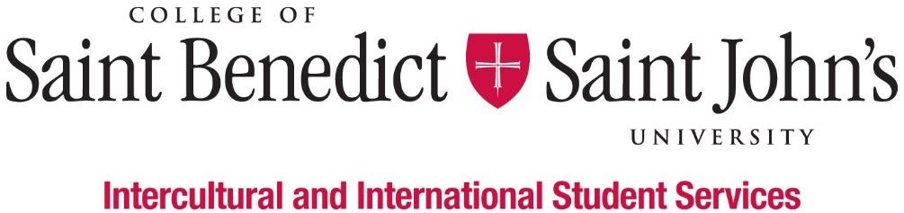
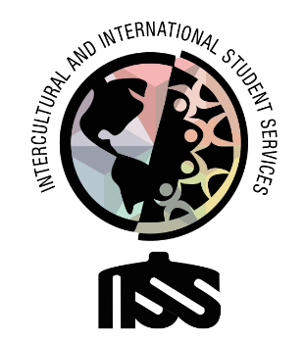

SafeSpace Educator

What We Believe: Intercultural and International Student Services believes that learning to effectively navigate differences and new environments is an essential part of a liberal arts education. Our Inclusion Visioning Statement calls us to integrate this priority into all aspects of the life of the institutions.
Our Vision: Intercultural and International Student Services aspires to model transformative inclusion in our immediate and global communities.
Our Mission: Intercultural and International Student Services empowers and educates students to intentionally develop mutually trusting and culturally agile relationships.
We’ll know we’ve succeeded when: All students feel like they belong and are successful at CSBSJU.
Length of Position:
- 2020 – 2021 Academic Year
Description of Position:
We are looking for a person who is a pleasing and personable who is able to handle stressful situations (like homophobia, biphobia, xenophobia, or transphobia) and has exceptional presentation, communication, media, professional, social, and time management skills – all things pertaining to the coordination and execution of SafeSpace trainings.
Duties & Responsibilities:
- Be responsible for designing, delivering, and evaluating SafeSpace trainings with special emphasis on utilizing different modes of delivery and integrating an intersectional awareness and approach
- Schedule and invite participation in SafeSpace trainings by reaching out to campus offices, organizations, faculty, and staff who have expressed interest or have recommendations for training
- Provide support and resources for folks who complete the training and following up with them in the future with links to new terms, vocabulary, inclusive practices, LGBTQ+ issues, etc.
- Be extremely knowledgeable about LGBTQIA+ issues within society, terminology, and ways to advance a sense of transformative inclusion and belongingness
- Be actively engaged in advocating and planning for PRiSM to be housed in an LGBTQ+ resource center
Minimum qualification to perform the duties of the position:
- Ability to work independently and as a team member
- Basic Knowledge of Outlook, Excel, Instagram, Facebook, Twitter, LinkedIn, and other social media platforms
- Attention to detail
- Good written and verbal communication skills, with comfort and competence in public speaking
- Attend development workshops for the job and the department
- Have a strong interest in inclusion and cultural agility
- Ability or experience in intercultural contexts and willingness to work with people from many different backgrounds
- Willing to take initiative
- Be able to prioritize multiple projects and requests appropriately
- Good academic standing (minimum GPA 2.0) and not on Probation for disciplinary reasons
Work Schedule:
- Monday – Friday, various hours 8am – 4:30pm; Nights and weekends as appropriate;
- Attend scheduled staff meetings and trainings;
- Training in August (starting on August 13) and early January.
To apply for this position, please complete the online application by Friday, April 10, 2020.

