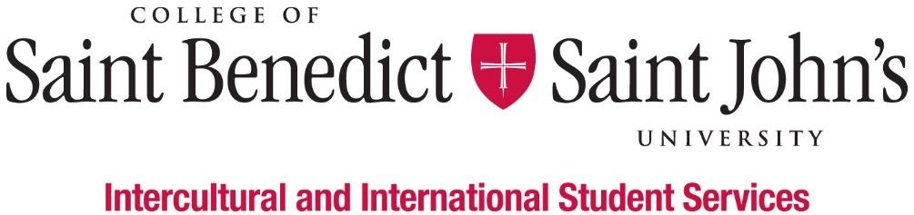
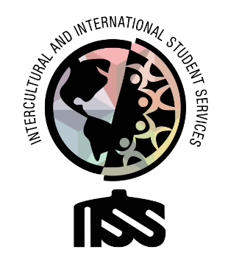

Restorative Justice Facilitator and Programming Coordinator

What We Believe: Intercultural and International Student Services believes that learning to effectively navigate differences and new environments is an essential part of a liberal arts education. Our Inclusion Visioning Statement calls us to integrate this priority into all aspects of the life of the institutions.
Our Vision: Intercultural and International Student Services aspires to model transformative inclusion in our immediate and global communities.
Our Mission: Intercultural and International Student Services empowers and educates students to intentionally develop mutually trusting and culturally agile relationships.
We’ll know we’ve succeeded when: All students feel like they belong and are successful at CSBSJU.
Length of Position:
- 2020 – 2021 Academic Year
Description of Position:
We are looking for a student who is interested in the philosophy and practice of restorative justice as a means to build community, repair harm, and rebuild trust. Restorative Justice is a theory of justice that emphasizes repairing the harm caused by criminal behavior. In the context of our community, we are focusing more on discriminatory, exclusionary, and harmful behaviors that make people feel as if they don’t belong, aren’t included, and are not welcome.
Duties & Responsibilities:
- Organize and facilitate formal and informal restorative justice (RJ) practices, as appropriate
- Keep excellent and accurate data on interventions, agreements, and outcomes
- Consistently administer evaluations to all parties involved in RJ interventions
- Solicit, encourage, maintain regular contact with, and support student RJ facilitators
- Manage and hold confidential sensitive information
- Perform other work-related duties as assigned
Minimum qualification to perform the duties of the position:
- Ability to work independently and as a team member
- Basic Knowledge of Outlook, Excel, Instagram, Facebook, Twitter, LinkedIn, and other social media platforms
- Attention to detail
- Good written and verbal communication skills, with comfort and competence in public speaking
- Attend development workshops for the job and the department
- Have a strong interest in inclusion and cultural agility
- Ability or experience in intercultural contexts and willingness to work with people from many different backgrounds
- Willing to take initiative
- Be able to prioritize multiple projects and requests appropriately
- Good academic standing (minimum GPA 2.0) and not on Probation for disciplinary reasons
Work Schedule:
- Monday – Friday, various hours 8am – 4:30pm; Nights and weekends as appropriate;
- Attend scheduled staff meetings and trainings;
- Training in August (starting on August 13) and early January.
To apply for this position, please complete the online application by Friday, April 10, 2020.

