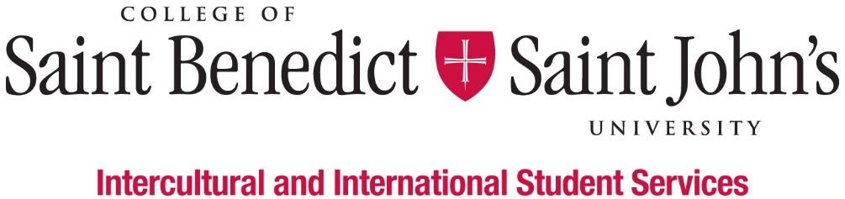
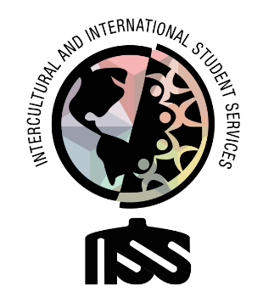

International Student Mentor

What We Believe: Intercultural and International Student Services believes that learning to effectively navigate differences and new environments is an essential part of a liberal arts education. Our Inclusion Visioning Statement calls us to integrate this priority into all aspects of the life of the institutions.
Our Vision: Intercultural and International Student Services aspires to model transformative inclusion in our immediate and global communities.
Our Mission: Intercultural and International Student Services empowers and educates students to intentionally develop mutually trusting and culturally agile relationships.
We’ll know we’ve succeeded when: All students feel like they belong and are successful at CSBSJU.
Length of Position:
- 2020 – 2021 Academic Year
Description of Position:
We are looking for individuals with warm welcoming personalities who are very easily approachable to serve as a mentor and welcome people into the IISS office. Mentors will help with the academic, personal, and professional development of their international student “mentees” as they navigate their first year at CSB|SJU.
Duties & Responsibilities:
- Mentor new international students including assisting with transition to CSB|SJU, monthly meetings and reports, and regular check-in’s with mentees
- Facilitate various intercultural competence lessons (primarily by occasional attendance at orientation class for international students)
- Assist with and participate in IISS events and programs
- Collaborate with other Student Clubs and Organizations on campus
- Act as a confidante and liaison providing interculturally appropriate advice and guidance as necessary
- Promote cultural interaction between international students, underrepresented students, and US students at CSB|SJU and the surrounding communities
- Work and Staff Office during work hours
- File and Organize Data via Excel, Word and NIBRAS System
- Handle confidential information
Minimum qualification to perform the duties of the position:
- Ability to work independently and as a team member
- Basic Knowledge of Outlook, Excel, Instagram, Facebook, Twitter, LinkedIn, and other social media platforms
- Attention to detail
- Good written and verbal communication skills, with comfort and competence in public speaking
- Attend development workshops for the job and the department
- Have a strong interest in inclusion and cultural agility
- Ability or experience in intercultural contexts and willingness to work with people from many different backgrounds
- Willing to take initiative
- Be able to prioritize multiple projects and requests appropriately
- Good academic standing (minimum GPA 2.0) and not on Probation for disciplinary reasons
Work Schedule:
- Monday – Friday, various hours 8am – 4:30pm; Nights and weekends as appropriate;
- Attend scheduled staff meetings and trainings;
- Training in August (starting on August 13) and early January.
To apply for this position, please complete the online application by Friday, April 10, 2020.

