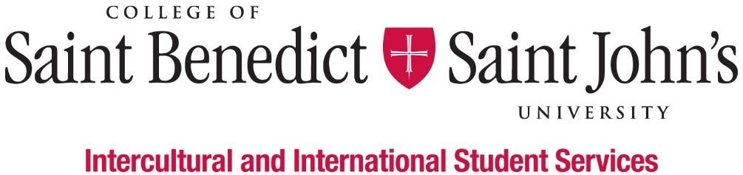
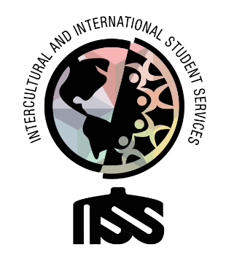

First-Generation Student (FGS) Faculty & Staff Mentoring Program Coordinator

What We Believe: Intercultural and International Student Services believes that learning to effectively navigate differences and new environments is an essential part of a liberal arts education. Our Inclusion Visioning Statement calls us to integrate this priority into all aspects of the life of the institutions.
Our Vision: Intercultural and International Student Services aspires to model transformative inclusion in our immediate and global communities.
Our Mission: Intercultural and International Student Services empowers and educates students to intentionally develop mutually trusting and culturally agile relationships.
We’ll know we’ve succeeded when: All students feel like they belong and are successful at CSBSJU.
Length of Position:
- 2020 – 2021 Academic Year
Description of Position:
We are looking for a student who is well-organized, a good communicator, task-oriented, and comfortable taking initiative and working independently to assist the first-gen faculty/staff mentoring program.
Duties & Responsibilities:
- Assistant the First-gen Student Success Advisor to coordinate/facilitate meetings for faculty/staff mentors and student mentees
- Reaching out to student mentees and faculty/staff mentors about the mentoring program events, activities, programming
- Provide mentor-mentee mixer event assistance to the supervisor
- Assist the supervisor to connect with the alums for senior first-generation student mentoring; Provide peer mentoring service to seniors
- Serve as a voice and an advocate for first-generation students and be a resource to members of the campus community, who seek assistance and promote understanding of first-generation students and the notion of “proud to be first-gen”
- Serve as a liaison between the supervisor, the organization, organization members, the first-generation students, and faculty/staff mentors at CSBSJU
- Perform other work-related duties as assigned
Minimum qualification to perform the duties of the position:
- Ability to work independently and as a team member
- Basic Knowledge of Outlook, Excel, Instagram, Facebook, Twitter, LinkedIn, and other social media platforms
- Attention to detail
- Good written and verbal communication skills, with comfort and competence in public speaking
- Attend development workshops for the job and the department
- Have a strong interest in inclusion and cultural agility
- Ability or experience in intercultural contexts and willingness to work with people from many different backgrounds
- Willing to take initiative
- Be able to prioritize multiple projects and requests appropriately
- Good academic standing (minimum GPA 2.0) and not on Probation for disciplinary reasons
Work Schedule:
- Monday – Friday, various hours 8am – 4:30pm; Nights and weekends as appropriate;
- Attend scheduled staff meetings and trainings;
- Training in August (starting on August 13) and early January.
To apply for this position, please complete the online application by Friday, April 10, 2020.

