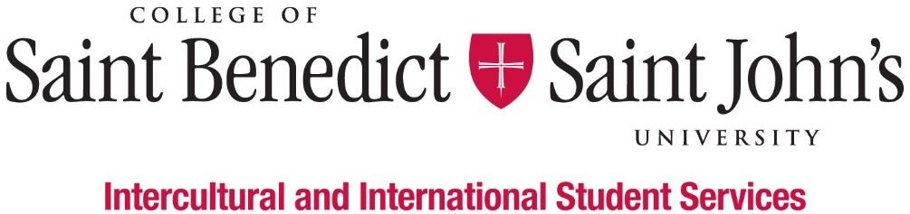
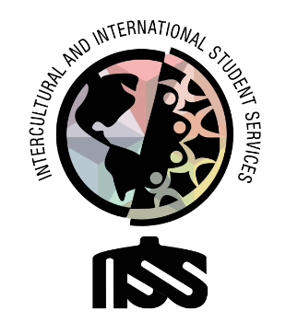

First-Generation Student (FGS) Event Planning and Programming Coordinator

What We Believe: Intercultural and International Student Services believes that learning to effectively navigate differences and new environments is an essential part of a liberal arts education. Our Inclusion Visioning Statement calls us to integrate this priority into all aspects of the life of the institutions.
Our Vision: Intercultural and International Student Services aspires to model transformative inclusion in our immediate and global communities.
Our Mission: Intercultural and International Student Services empowers and educates students to intentionally develop mutually trusting and culturally agile relationships.
We’ll know we’ve succeeded when: All students feel like they belong and are successful at CSBSJU.
Length of Position:
- 2020 – 2021 Academic Year
Description of Position:
We are looking for a student who is well-organized, a good communicator, task-oriented, and comfortable taking initiative and working independently to make sure all aspects of events and programs organized for FGS run smoothly and are well-attended and evaluated by first-generation students (FGS).
Duties & Responsibilities:
- Organize First-generation Student Organization Committee meetings and collect ideas about events and programs from the organization’s (committee) members
- Provide event/programming assistance to the first-gen student support specialist
- Design and market events and programs to support all first-generation students to succeed at CSBSJU
- Serve as a voice and an advocate for first-generation students and be a resource to members of the campus community, who seek assistance and promote understanding of first-generation students and the notion of “proud to be first-gen”
- Serve as a liaison between the supervisor, the organization, organization members, and the first-generation students at CSBSJU
- Event coordination of before, during, and after; Schedule room reservations for events/programs/meetings and make catering and food service arrangements
- Assist with event/program participation data collection
- Perform other work-related duties as assigned
Minimum qualification to perform the duties of the position:
- Ability to work independently and as a team member
- Basic Knowledge of Outlook, Excel, Instagram, Facebook, Twitter, LinkedIn, and other social media platforms
- Attention to detail
- Good written and verbal communication skills, with comfort and competence in public speaking
- Attend development workshops for the job and the department
- Have a strong interest in inclusion and cultural agility
- Ability or experience in intercultural contexts and willingness to work with people from many different backgrounds
- Willing to take initiative
- Be able to prioritize multiple projects and requests appropriately
- Good academic standing (minimum GPA 2.0) and not on Probation for disciplinary reasons
Work Schedule:
- Monday – Friday, various hours 8am – 4:30pm; Nights and weekends as appropriate;
- Attend scheduled staff meetings and trainings;
- Training in August (starting on August 13) and early January.
To apply for this position, please complete the online application by Friday, April 10, 2020.

