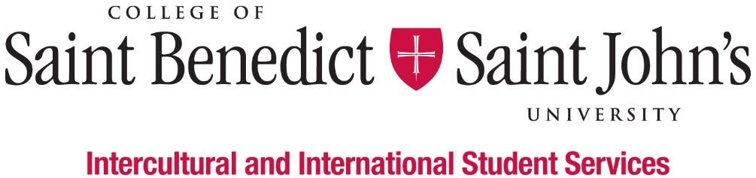
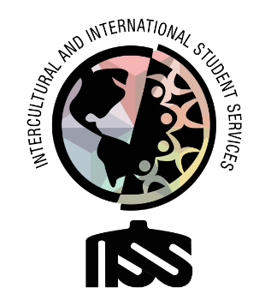

Peer Mentor for First-Generation Students

What We Believe: Intercultural and International Student Services believes that learning to effectively navigate differences and new environments is an essential part of a liberal arts education. Our Inclusion Visioning Statement calls us to integrate this priority into all aspects of the life of the institutions.
Our Vision: Intercultural and International Student Services aspires to model transformative inclusion in our immediate and global communities.
Our Mission: Intercultural and International Student Services empowers and educates students to intentionally develop mutually trusting and culturally agile relationships.
We’ll know we’ve succeeded when: All students feel like they belong and are successful at CSBSJU.
Length of Position:
- 2020 – 2021 Academic Year
Description of Position:
We are looking for one SJU-enrolled and one CSB-enrolled student with warm and welcoming personalities who are very easily approachable to serve as a mentor and welcome people into the IISS office. Mentors will help with the academic, personal, professional development of their student “mentees” as they navigate their life at CSBSJU.
Duties & Responsibilities:
- Mentor first-generation students in specific years and help them to succeed at CSBSJU
- Serve as a voice and an advocate for first-generation students and be a resource to members of the campus community, who seek assistance is promoting awareness/understanding first-generation students and “proud to be first-gen”
- Serve as a liaison between the supervisor, the organization, organization members, and the first-generation students at CSBSJU
- Assisting program data collection and evaluation
- Create and support a welcoming environment at IISS for people to express their concerns, share their questions
- Coordinate and deliver presentations to the CSBSJU community on issues of equity, diversity, inclusion, and justice
- Fulfill day-to-day office tasks requested by supervisors and co-workers
- Perform other work-related duties as assigned
Minimum qualification to perform the duties of the position:
- Ability to work independently and as a team member
- Basic Knowledge of Outlook, Excel, Instagram, Facebook, Twitter, LinkedIn, and other social media platforms
- Attention to detail
- Good written and verbal communication skills, with comfort and competence in public speaking
- Attend development workshops for the job and the department
- Have a strong interest in inclusion and cultural agility
- Ability or experience in intercultural contexts and willingness to work with people from many different backgrounds
- Willing to take initiative
- Be able to prioritize multiple projects and requests appropriately
- Good academic standing (minimum GPA 2.0) and not on Probation for disciplinary reasons
Work Schedule:
- Monday – Friday, various hours 8am – 4:30pm; Nights and weekends as appropriate;
- Attend scheduled staff meetings and trainings;
- Training in August (starting on August 13) and early January.
To apply for this position, please complete the online application by Friday, April 10, 2020.

