Take Home Final Exam:
(Open book!)
Analyzing data

This is the practical exam. It is an opportunity to showcase your ability to analyze data using the tools we studied this semester. Keep in mind that:
- Using the right tool in the right situation is VERY important.
- Providing a substantive interpretation of your results is VERY important.
- You should make full use of your book and class notes.
- You should work on this assignment alone. If I hear that students are working together on this exam, the students will receive a failing grade. If you have any questions, direct them to Prof. Court.
- You should have fun with this!

Answer the question below using the ‘States’ Full Version (not the student version) data set. Be very clear about the point you are addressing and be careful to cover all points below (type your answer using this document as a template). Upload this completed take home to Canvas.

What is the effect of having a college education on turning out to vote in the 2012 election, by state?

Step 1 (20 points):
- Identify
  - the dependent variable
  - the independent variable
  - the unit of analysis
  - the type of study
- Write your hypothesis.
- Identify the variables in the data set that will allow you to test the relationship described in your hypothesis (write down the variable names).
- Describe the operationalization of the two variables (How are they measured in the data set? Are they interval or categorical? What is the range of values for each variable?)

Step 2 (30 points): Meets Criteria 2. Representing Data Visually, Numerically, and Verbally.
- Transform at least one of the variables (from interval to categorical; think carefully about whether you want to transform the dependent or the independent variable!!) and explain why you transformed it the way you did.
- Provide appropriate univariate statistics (and brief interpretation) for your variables
  - Univariate statistics for the original form variables (before you transformed either or both)
  - Univariate statistics for the transformed variable(s)
  - Include output!

Step 3 (30points): Meets Criteria 2. Representing Data Visually, Numerically, and Verbally,
3a. Analyze/Estimate Numerical Information and 4. Draw Conclusion in Context, based on numerical Information
- Provide exploratory bivariate statistics (think in terms of relevant statistics, tables, and graphics) corresponding to your hypothesis
  - Using both variables in the original form (before transformation)
  - Using the transformed variable(s) and the original form variables, where applicable
  - Select the appropriate exploratory statistics and interpret them in context. Be detailed! (What conclusions can you draw about the sample? What conclusions can you draw about the population?)
  - What do these results tell us about the role of education in our democracy?
  - Include appropriate output (tables and graphs)

Step 4 (20points): The Following Section Meets Criteria 1a & 1b Interpret and Draw Conclusions from Previously Existing

Please see next page for image and questions

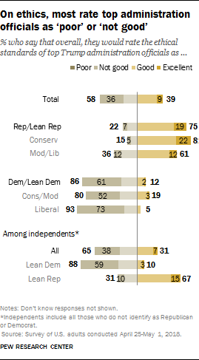

8a. Circle what kind of study is represented in the figure.

Longitudinal Cross-sectional Panel

8b. What are the variables and what is the unit of analysis represented in this figure? (3 pts.)

Independent Variable ________________________________

Dependent Variable _________________________________

Unit of analysis ______________________________________

8c. Write a hypothesis for this relationship. (2 pts)

8d. Explain this figure in terms of the relationship between the independent and dependent variables and explain what implications this may have for the 2020 presidential election. (6 pts)
Meets Criteria 1b. Draw Conclusions from Previously Existing Graphs, Tables, and/or Schematics.

Please use the following table to answer questions:

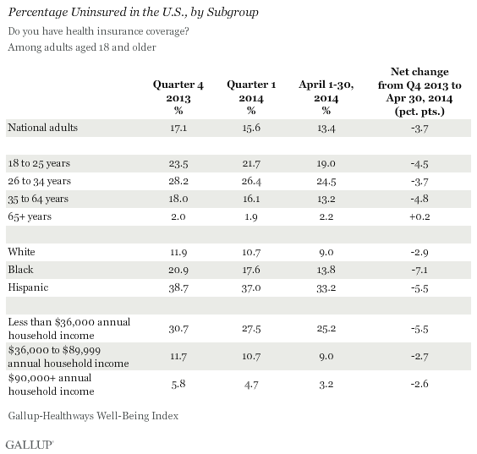

9a. Circle what kind of study is represented in the figure (2 pts).

Longitudinal Cross-sectional Panel

9b Pick one independent and the dependent variable from the table and write them below. (2 pts.)

Independent Variable ________________________________

Dependent Variable _________________________________

9c. Write a hypothesis for this relationship. (2 pts)

9d. Explain the results from the table in terms of the relationship between the independent and dependent variable. (4 pts)

9e. What do these results tell us about who is most likely to be affected by a repeal of the Affordable Care Act? Explain how this information could be used by Republicans and Democrats to strategizes in the next presidential election. (6 pts)
Meets Criteria 1b. Draw Conclusions from Previously Existing Graphs, Tables, and/or Schematics.

