Is the nares width of humans related to climate?
Introduction:
Inhaled air reaches 90% of the required temperature and humidity levels before even reaching the nasopharynx
The geometry of the nasal airways influences the velocity of inspired air. Narrow airways in cold-dry climates might allow better conditioning by increasing the turbulence in inspired air as it reaches the turbinates, thereby facilitating contact with the nasal mucosa.
However, we note that nostril area does not show unusually high differentiation across populations, which suggests that it is not the size of the nostrils but the shape that might be functionally important.

Several studies have shown that the shapes of the nasal aperture and nasal cavity are correlated with climate variables related to temperature and humidity such that individuals from cold-dry climates exhibit narrower nasal cavities compared to individuals from warm humid climates.

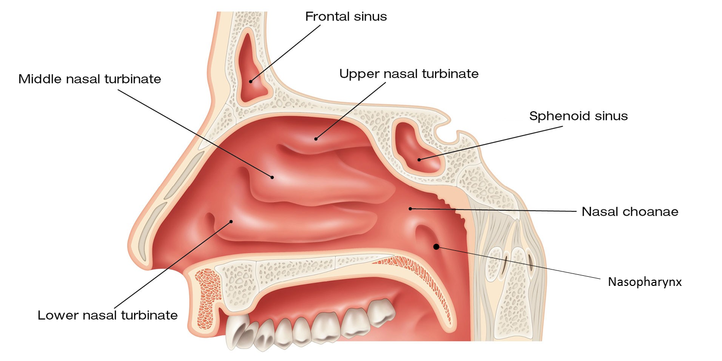

As a group record your hypothesis and prediction below

Other than nares width, what other useful measurements should be recorded?

What variables need to be controlled or minimized?
Human Evolution – Noses Data Entry Sheet – Day 1

Nares width (mm) | Race | Biological Gender | Age
Options | African  European  Middle Eastern  Asian  Australian  North American  South American | Male  Female | 17-22  23-30  31-50  older than 50

Step 1. Measure the nares width of test subject’s nose. Measurement should be in millimeters.

Step 2. Have test subject identify ancestral racial groupings. If their parents/grandparents come from multiple ancestries have them choose one based on their perceived facial structures.

Step 3. Record biological gender (not what gender they identify with, but what they were born with).

Step 4. Record test subject’s age range.

Step 5. Enter Data into Google Sheets in Canvas by Friday, Sept 28th at 8am
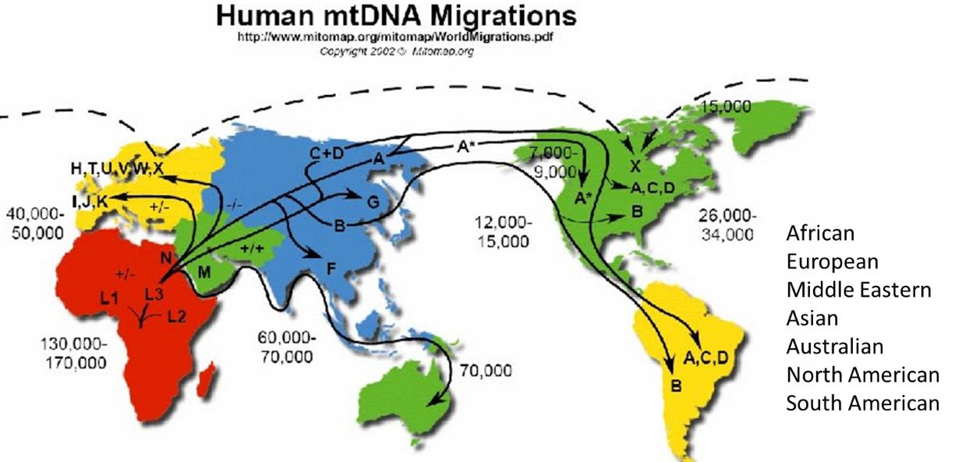
Human Evolution – Day 2 – Making and Interpreting a Figure

1. Calculate the following values with the data collected about the nares width.
Meets criteria 2
 | Female | Male
Mean
St. dev
n

2. Based on your calculated values above, which measure of central tendency and dispersion should be reported?

3. Construct a scientifically formatted figure. *Note, the professor could take the data and provide students with a figure like the one I’ve put below.*
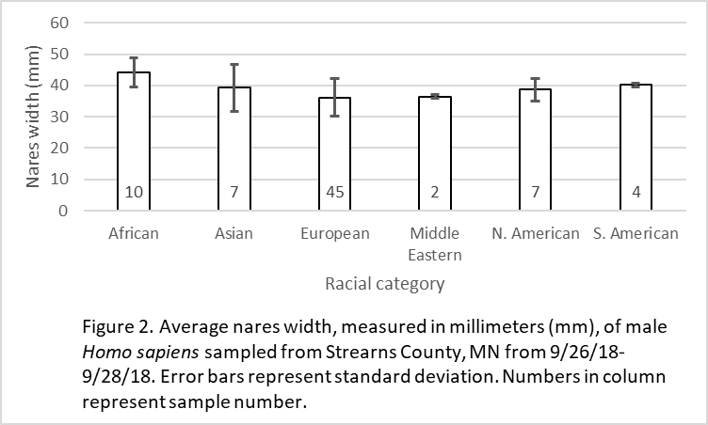
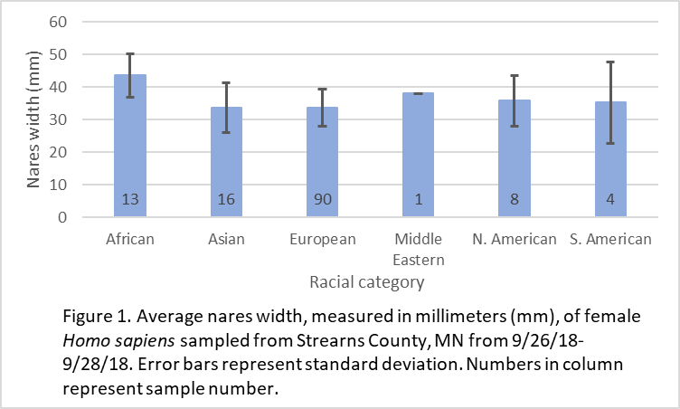
Meets criteria 2

4. Write a Results narrative describing the figures. Make sure to describe relevant trends and reference the relevant data.
This section meets criteria 1a if the figures are provided for students.
If students calculate values and construct figures on their own this section meets criteria 3a.

5. Write a Conclusions section.
This section meets criteria 1b if the figures are provided for students.
If students calculate values and construct figures on their own this section meets criteria 4.
a. Was your hypothesis supported?
b. How confident are you in your conclusions?
c. Make sure that you draw connections to natural selection and evolution.

6. What is an alternative explanation for the results based on the data.
This section meets criteria 3b.

