December 2012 Graduates
Majors
Jacob Haarstad
Major(s): English
Minor(s):
Special achievements:

Immediate plans after graduation:

Johanna Holub  Major(s): English/Hispanic Studies  Minor(s): None  Special achievements:  Magna Cum Laude, Gable Family Scholarship  Immediate plans after graduation:  Working full-time as a staff writer for Lillie Suburban Newspapers: Oakdale-Lake Elmo Review and the Ramsey County-Maplewood Review. | 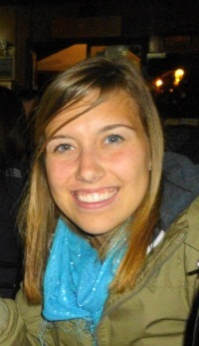
Ruairi Moynihan
Major(s): English
Minor(s): Secondary Education
Special achievements:
Dean’s List, All-Conference Honors in Cross Country and Track
Immediate plans after graduation:
High School Language Arts Teacher in Phoenix, AZ through Teach for America.
Mara Pieper
Major(s): English/Hispanic Studies
Minor(s):
Special achievements: Magna Cum Laude, Phi Beta Kappa

Immediate plans after graduation: I am currently working as a Business Development Consultant at Oracle in Austin, TX.
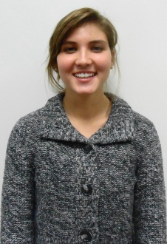 | Ann Rogosheske  Major(s): English/PCST  Minor(s): HUMN  Special achievements:  Immediate plans after graduation:
Callan Sleper  Major(s): English  Minor(s): POLS  Special achievements:  Immediate plans after graduation: | 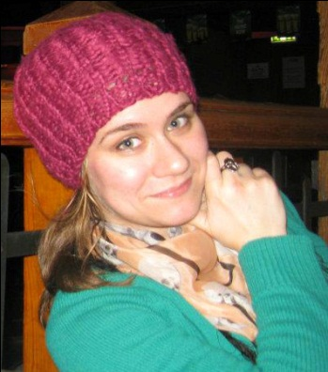
Alison Tsuchiya
Major(s): Comm/English
Minor(s): SCED
Special achievements:

Immediate plans after graduation:

Olivia Wee  Major(s): English  Minor(s): SCED  Special achievements:  Immediate plans after graduation: | 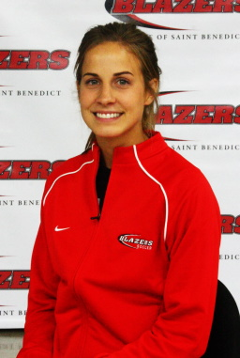

& May 2013 Graduates
Majors
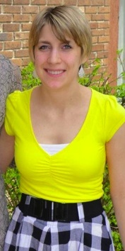 | Laurie Bachman  Major(s): English  Minor(s): None  Special achievements:  Cum Laude  Immediate plans after graduation:  I’m going to Winona State to get my MA in Special Education.
Brittany Basden  Major(s): English  Minor(s): Gender  Special achievements:  Immediate plans after graduation: | 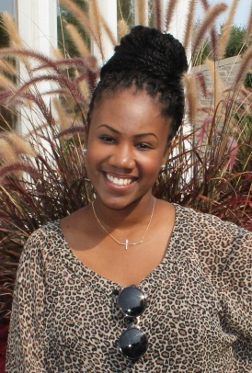
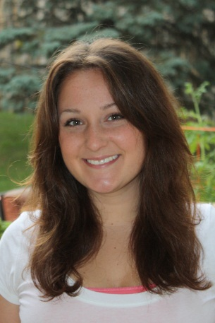 | Kathryn Bauer  Major(s): Communication/English  Minor(s):  Special achievements:  Immediate plans after graduation:
Aaron Beyer  Major(s): English/PSYC  Minor(s):  Special achievements:  Immediate plans after graduation: | 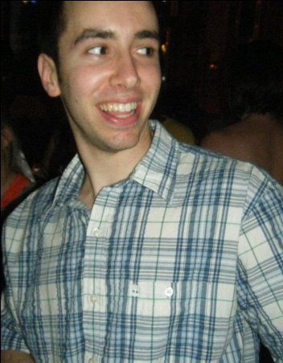
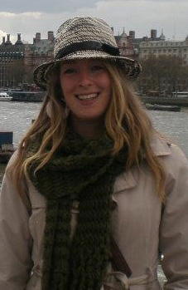 | Elizabeth Bissonette  Major(s): English  Minor(s): SCED  Special achievements:  Immediate plans after graduation:
Emily Boeckmann  Major(s): English/ Communication  Minor(s):  Special achievements: Magna Cum Laude, Scholarship and Creativity Day Presenter  Immediate plans after graduation: ??? | 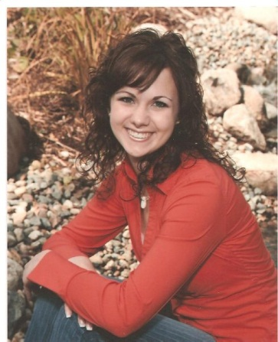
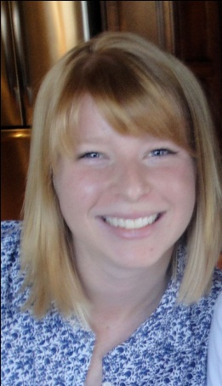 | Kelly Butorac  Major(s): Comm/English  Minor(s):  Special achievements:  Immediate plans after graduation:
Katherine Chambers
Major(s): English
Minor(s): Political Science
Special achievements:
Creative Cloud AmeriCorps Program

Immediate plans after graduation:
Looking to work at the Loft Literary Center, or with AmeriCorps in the fall.
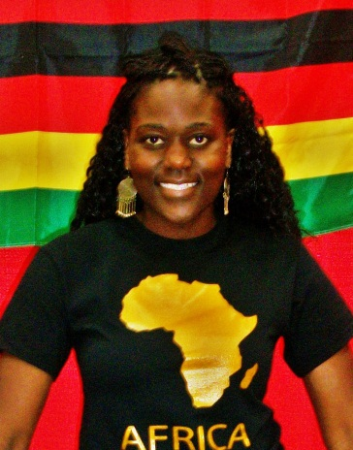 | Paidamoyo Chikate  Major(s): English/THEA  Minor(s):  Special achievements:  Immediate plans after graduation:
Nicholas Crowley  Major(s): English/THEA  Minor(s):  Special achievements:  Immediate plans after graduation: | 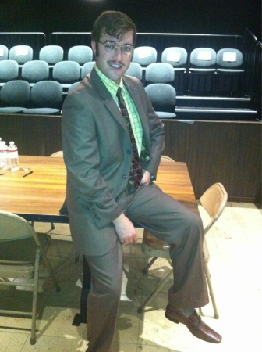
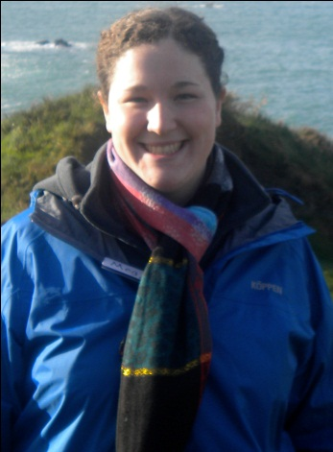 | Margaret Deignan  Major(s): English  Minor(s): SCED, Music  Special achievements:  Immediate plans after graduation:
Hannah Dolan  Major(s): English/POLS  Minor(s):  Special achievements:  Immediate plans after graduation: | 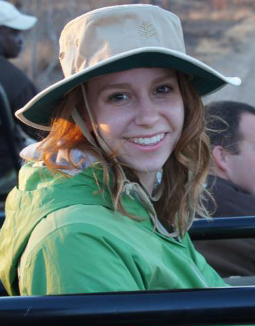
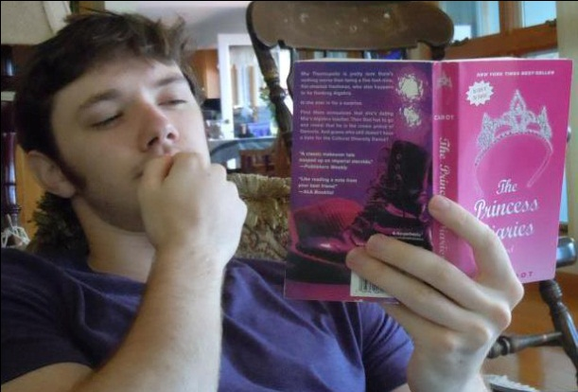 | Matthew Doyle  Major(s): English  Minor(s): Secondary Education  Special achievements:  Immediate plans after graduation: Work.
Theresa Flahaven  Major(s): English  Minor(s): History  Special achievements:  Immediate plans after graduation: | 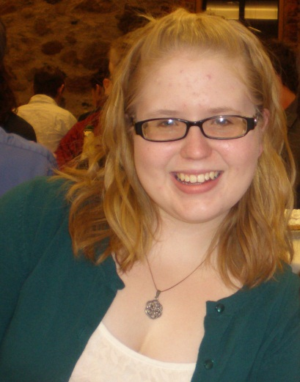
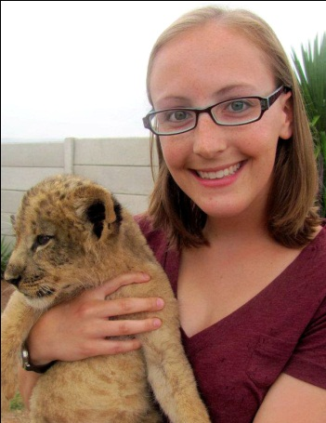 | Emily Gasperlin  Major(s): English  Minor(s): Communications  Special achievements: SCD Presentation, graduating Summa Cum Laude.  Immediate plans after graduation: Still looking for an internship.
Eleanor Gray  Major(s): English  Minor(s): ENVR  Special achievements:  Immediate plans after graduation: | 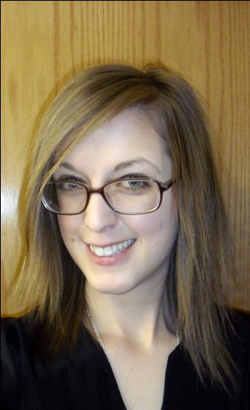
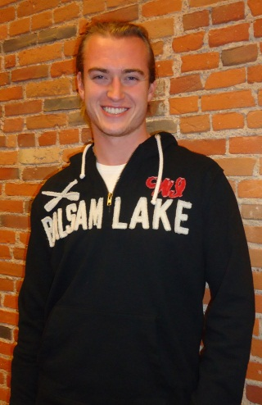 | Connor Grill  Major(s): English/History  Minor(s):  Special achievements: All-College Honors, All-American DIII Football, All-Conference MIAC.  Immediate plans after graduation: Apply to MFA graduate programs.
Elizabeth Hagen  Major(s): English  Minor(s): Biology, Pre-med  Special achievements:  Immediate plans after graduation:  Take a year off working as a CAN, then Medical school. | 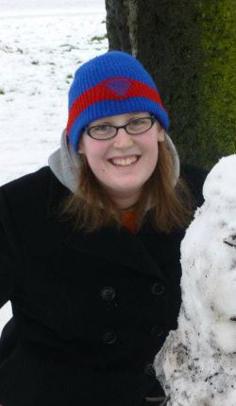
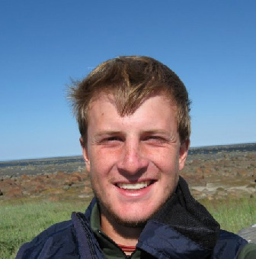 | Jacob Harris  Major(s): English  Minor(s):  Special achievements:  Immediate plans after graduation:
Andrew Hilger  Major(s): English  Minor(s):  Special achievements:  Immediate plans after graduation: | 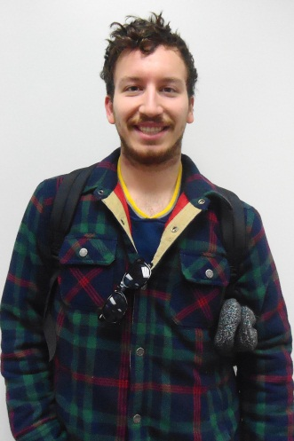
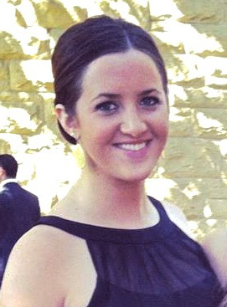 | Bridget Hooley  Major(s): English  Minor(s): Secondary Education  Special achievements:  Immediate plans after graduation:  Applying to be a middle or high school Language Arts teacher in MN.
Hudda Ibrahim  Major(s): English  Minor(s): PCST  Special achievements:  Immediate plans after graduation: | 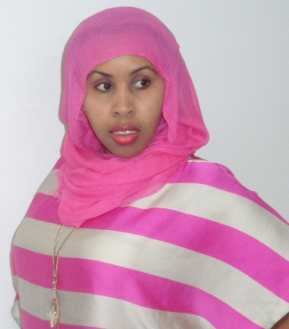
Taylor Jacobs
Major(s): English
Minor(s): Secondary Education
Special achievements:

Immediate plans after graduation:
Rachel Kebe  Major(s): English  Minor(s): Communication  Special achievements:  Member of Alpha Kappa Sigma and HAIS  Immediate plans after graduation:  I will be moving back to Kansas City, Kansas for the summer to pursue full/part-time jobs and fall internships in the Twin Cities/Chicago area. | 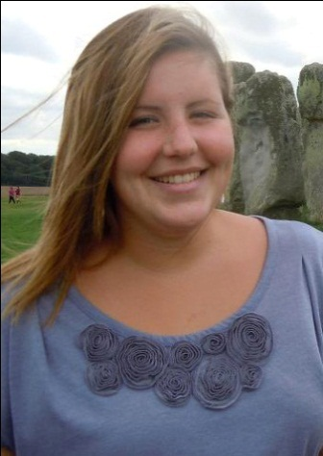
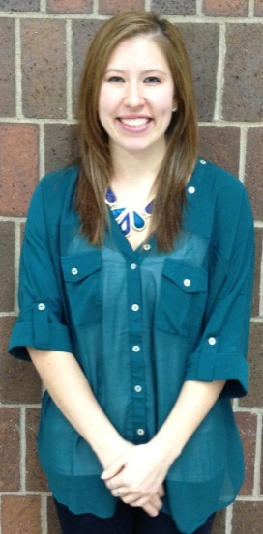 | Lauren Kelleher  Major(s): English  Minor(s): SCED  Special achievements:  Immediate plans after graduation:
Jamie Korin  Major(s): English/Hispanic Studies  Minor(s): None  Special achievements:  Phi Beta Kappa, Summa Cum Laude  Immediate plans after graduation:  I will be looking for full-time employment. | 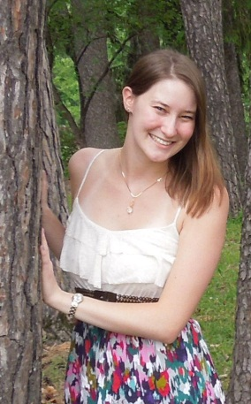
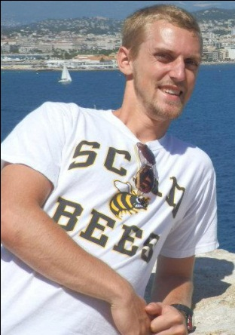 | Michael Kuhlman  Major(s): English  Minor(s): French  Special achievements:  Supervisor of the SJU Writing Center; two sport athlete.  Immediate plans after graduation:  Technical Writing.
Cody Maynus  Major(s): English  Minor(s): GEND/THEO  Special achievements:  Immediate plans after graduation: | 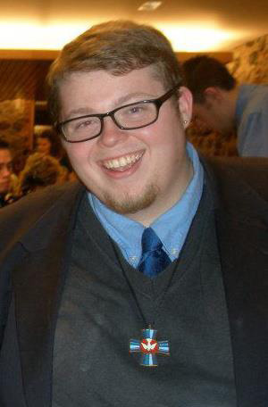
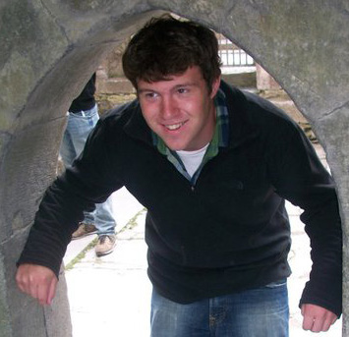 | Joseph McQuillan  Major(s): Comm/English  Minor(s):  Special achievements:  Immediate plans after graduation:
Aaron Menzel  Major(s): English  Minor(s): Secondary Education  Special achievements:  Immediate plans after graduation: | 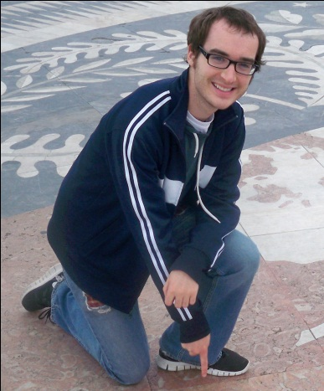
Hannah Miller
Major(s): English
Minor(s):
Special achievements:

Immediate plans after graduation:

William Moore  Major(s) : English  Minor(s): Music  Special achievements:  Immediate plans after graduation: | 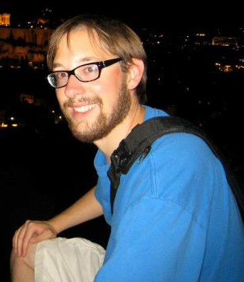
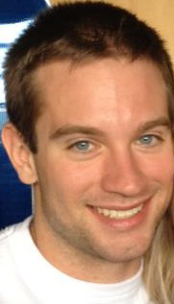 | Michael Olson  Major(s) : English  Minor(s): Exercise Science and Sport Studies  Special achievements:  Immediate plans after graduation:  Personal Training and hopefully attaining my certification to be a Certified Strength and Conditioning Specialist.
Sarah Osberg  Major(s) : English  Minor(s): Secondary Education  Special achievements: Magna Cum Laude  Immediate plans after graduation:  Hopefully finding a job teaching English in a middle or high school. In the meantime, securing a summer position working with kids. | 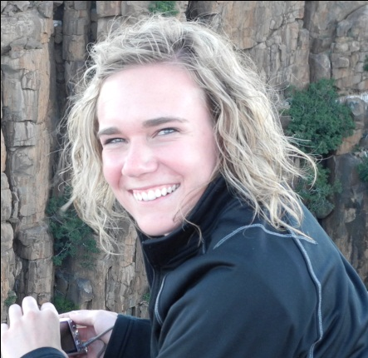
Tanner Petersen
Major(s) : English/Political Science
Minor(s):
Special achievements:
Honors Program.

Immediate plans after graduation:
Upon graduation I will be an office in the US Army Quartermaster Corps. I will attend my Basic Officer Leadership Course at Ft. Lee, VA from July 7-Oct 24, after which I will be stationed at a permanent assignment.
Amy Pinder  Major(s): English/Business Leadership  Minor(s):  Special achievements:  Cum Laude  Immediate plans after graduation:  Irma Wyman Development Internship at Hill Museum and Manuscript Library. | 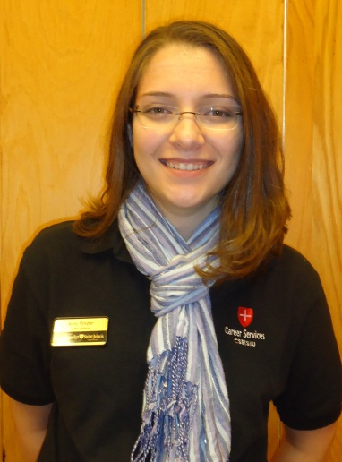
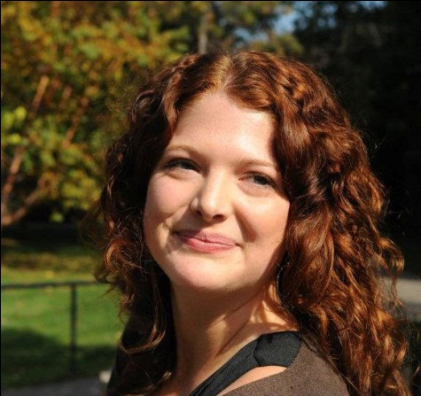 | Julia Segeleon  Major(s): English  Minor(s):  Special achievements: Phi Beta Kappa, Delta Epsilon Sigma, Summa Cum Laude, Dean’s List.  Immediate plans after graduation: I will be taking Education classes at Hamlin University. I will also be working for the MN Reading Corps.
Tyler Speltz  Major(s) : English  Minor(s): PHIL  Special achievements:  Immediate plans after graduation: | 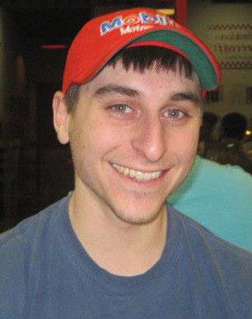
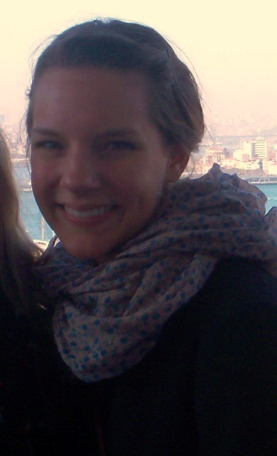 | Rachel Steenson  Major(s): English/Music  Minor(s):  Special achievements:  All College Honors, Summa Cum Laude  Immediate plans after graduation:
Katherine Umphress  Major(s): English  Minor(s): French  Special achievements:  Immediate plans after graduation:  Continue writing creatively in the hopes of publication, and job searching for full or part-time employment. | 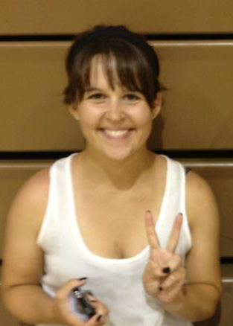
Jillian Wees
Major(s): English
Minor(s): Music
Special achievements:

Immediate plans after graduation:

Minors
Julie Bode
Major(s): PCST/HUMN
Minor(s): English
Special achievements:

Immediate plans after graduation:

Dana Johnson
Major(s): HIST
Minor(s): English
Special achievements:

Immediate plans after graduation:

Kelsey Koch  Major(s): Psychology  Minor(s): English-Writing  Special achievements: All College Honors, Distinction in Major, Dean’s List  Immediate plans after graduation: I plan to apply to graduate school for counseling psychology this fall. In the meantime, I am looking for jobs in the helping field. | 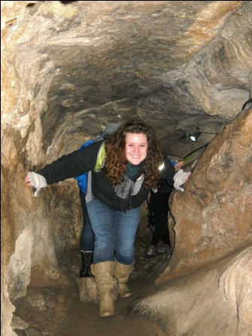
Devin Massopust
Major(s): POLS
Minor(s): English
Special achievements:

Immediate plans after graduation:

Katherine Takata
Major(s): THEA
Minor(s): English
Special achievements:

Immediate plans after graduation:

Claire Thibault
Major(s): Communication
Minor(s): English-Writing
Special achievements:

Immediate plans after graduation:
Working for Target as an Executive Team Leader.

Writing Minors
Kathleen Dierberger  Major(s): Theology  Minor(s): English Writing/Hispanic Studies  Special achievements:  Immediate plans after graduation:  The Echo Program through the University of Notre Dame. | 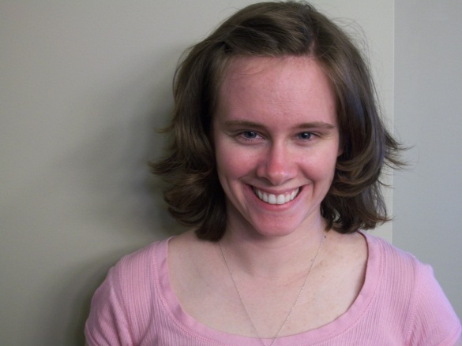
Angela Dols
Major(s): Psychology
Minor(s): English Writing
Special achievements:
Phi Beta Kappa

Immediate plans after graduation:
I’ll be working as an inclusion facilitator at Camp Butwin summer camp, then studying at Yeshivat Hadar in NYC for pre-rabbinic training.
Kia Lor  Major(s): Comm  Minor(s): ENGW  Special achievements:  Immediate plans after graduation: | 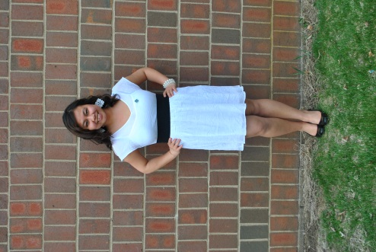
Ellen Newkirk
Major(s): Communication
Minor(s): English Writing
Special achievements:
Magna Cum Laude

Immediate plans after graduation:
I will be an ESL/Writing tutor for 3rd-8th graders through Amate House, a year-long volunteer program in Chicago.

Brady O’Brien
Major(s): Political Science
Minor(s): English Writing
Special achievements:
All-Conference Track and Field.
Immediate plans after graduation:
Moving to Los Angeles for the summer to work at a coffee shop with my brother.

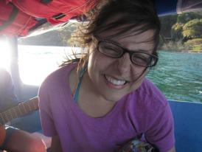 | Alivia Tison  Major(s): HISP  Minor(s): ENGW/LLAS  Special achievements:  Immediate plans after graduation:

