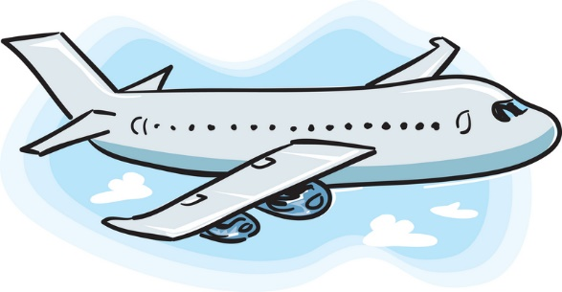
Transportation to/from MSP Airport for breaks & holidays

If you need transportation to/from the Minneapolis-St. Paul Airport, we encourage you to use one of these shuttle services. They offer online reservations, or you can call them directly.

Groom Transportation phone: 320-316-0943
Landline phone: 1-888-428-1149

Should you need financial assistance, you can submit a request to be reimbursed using this form: https://www.csbsju.edu/forms/4Z4OWUHECT

NOTE FOR LANDLINE: It is highly recommended to call them directly to make reservations and get a discount as a CSB/SJU student (student ID required to show driver). Using the online reservation system is an option, but it can be more complicated to apply discounts and book multiple riders. We encourage students to coordinate rides together as prices/rider are lower with a group. Please plan ahead – same day reservations are not an option.

