****

**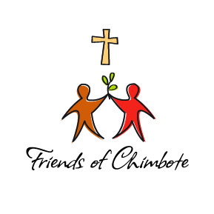**

**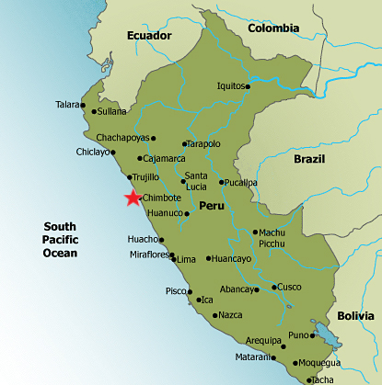**

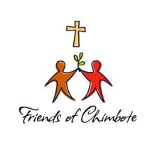

Dear Friends,

Hola y Bienvenidos a nuestra misión visita el programa! That’s Spanish for “Hello and welcome to our mission visit program!”

Our mission visit program began decades ago when mission founders, Father Jack Davis and Sister Peggy Byrne first began inviting people to Chimbote. Since then, thousands of people have answered the call and made a life-changing journey to our mission; many visiting more than once! They return home with a love for Chimbote in their hearts, never forgetting the sense of community that they experienced not only with fellow travelers but with the inspiring and loving people that they met and interacted with at the mission.

Because of the growth of our mission visit program we have established an experienced mission visit team to oversee all visitors and volunteer groups. This amazing group of ambassadors will ensure that your mission experience is one that transforms not only the lives of the poor, but yours as well. You will learn more about our team members and the services and support that we offer within this handbook.

An important first step is to read this handbook from front to back. No matter how much or how little travel experience you have; visiting and volunteering in Chimbote is a unique experience and we want you to be as prepared as possible. And while we’ve included many pages of helpful information it’s important to remember that your flexibility is an essential component of a good trip. Flight delays, lost baggage, weather, political demonstrations, labor unrest, cultural differences, and other unanticipated events may upset the best-laid plans. A willing spirit and a sense of humor can go a long way in making your mission visit enjoyable.

Once you have read this handbook and determine if a mission visit is for you the next step is to complete the appropriate application; either the short-term group application or our long-term-volunteer application where a 6-week minimum commitment is required. Both can be found on our website within our Mission Visit Toolkit.

*Buen viaje!* (Safe travels!) We wish you the most memorable trip of your life.

**Table of Contents**

|  |  |  |
| --- | --- | --- |
|  | **Welcome Letter** | page 2 |
|  | **Who We Are and What We Do** |  |
|  | •         Mission Statement/Programs and Services | page 4 |
|  | •         ACAF (Asociacion Civil Apoyo Familiar) | page 5 |
|  | •         Faith Statement/Our Lady of Perpetual Help parish | page 6 |
|  | **About Chimbote and Peru** |  |
|  | •         Politics & Economy | page 7 |
|  | •         Interesting Things to Know/Climate | page 8 |
|  | **Our Mission Visit Philosophy** | page 9 |
|  | **Health and Safety** |  |
|  | •         Immunizations | page 10 |
|  | •         How to Stay Healthy/Medications | page 10 |
|  | •         Travel Insurance & Safety Tips | page 11 |
|  | •         Mission Safety & Security Protocols | page 12 |
|  | **Currency and Money Considerations** | page 13 |
|  | **Let’s Get Started – Planning Your Trip** |  |
|  | •         Group Visits | page 14 |
|  | •         Volunteer Program | page 14 |
|  | •         Accommodations and Schedule | page 15 |
|  | •         Internet and Phone Service | page 15 |
|  | **Projects and Activities** |  |
|  | •         Descriptions and Costs | page 16 - 17 |
|  | **Travel Arrangements & Costs** |  |
|  | •         Airlines, Hotels and Buses | page 18-19 |
|  | **What to Pack** |  |
|  | •         Personal Packing List | page 20 |
|  | •         Home in a Bag | page 21 |
|  | •         Other Donations | page 22 |
|  | **Cultural Norms in Chimbote** |  |
|  | •         Do’s | page 23 |
|  | •         Don’ts | page 24 |
|  | **Helpful Spanish Phrases** | page 25 |
|  | **Contact Information** | page 26 |

**Who We Are**

**Friends of Chimbote** is a US-based 501(c)(3) non-profit organization responsible for the governance, global advocacy, and fundraising needed to sustain the life-changing mission programs and services in Chimbote now and into the evolving future. Our board of directors is comprised of members from throughout the United States; all who are passionate about the mission and empowering the poor.

Our offices are located in Fargo, North Dakota with dedicated staff members who work with thousands of individuals, civic groups, sister-parishes, and congregations to raise funds for mission programs, collect and ship donated goods to the mission and coordinate mission group visits and volunteer services.

### Our Mission Statement

*Friends of Chimbote is a faith based organization dedicated to supporting programs that improve and transform the lives of the poor of Chimbote, Peru.*

**Our Programs and Services**

The ultimate goal of Friends of Chimbote is to transform the poor of Chimbote into independent and self-supporting members of their community. We firmly believe that education is the primary means in which this can occur. However we recognize that there are basic needs that must be met before success can occur in the classroom and thereafter as people seek and find employment.

Within the first day or two of your visit, mission staff will provide you with a comprehensive overview and tour of the programs and services we offer. They include:

* **Education Programs**

From Early Childhood Stimulation to Vocational Programs for adults, mission programs provide education and support to people of all ages. Libraries and tutoring labs, computer classes, Dollars for Scholars and a Scholarship program are just some of the programs we offer.

# Social Programs & Family Development

The focus of our social programs is to help the poor of Chimbote get access to the most basic needs of human life ….food, water, shelter, clothing and a safe place to sleep. Only when those needs are met is the next step out of poverty possible.

# Healthcare

The Santa Ana Medical and Dental clinic provides basic healthcare services including prenatal and well-baby check-ups, general medical support, a pharmacy and dental clinic. Our Physical Rehab center provided therapy and massage for a variety of conditions. We also support the first known Hospice in all of South America.

# Business Development and Micro-Lending

Our business development and micro-lending programs pave the way for sustainable change that empowers those living in poverty to become self-supporting members of their community.

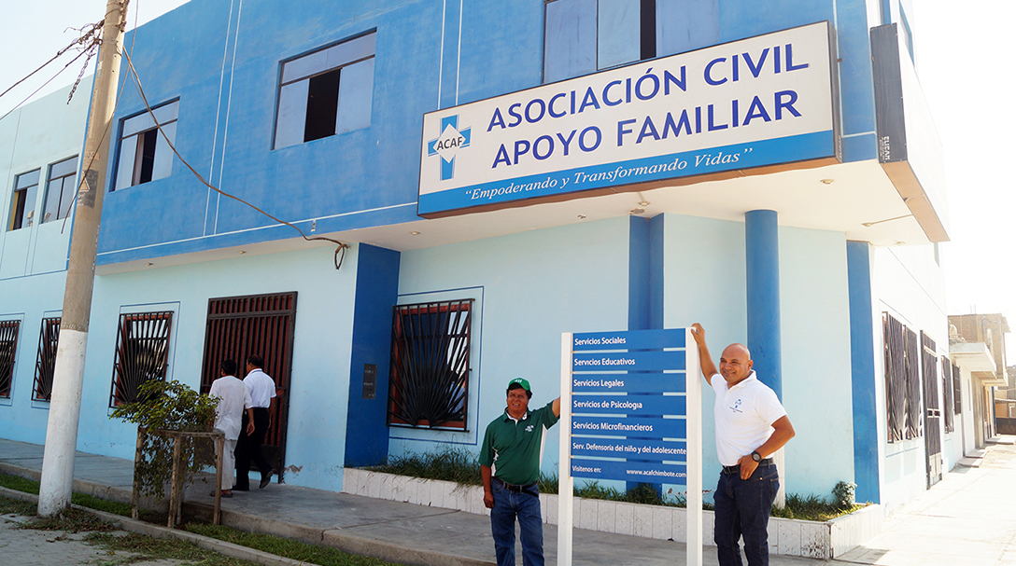

### Partnering with Asociacion Civil Apoyo Familiar (ACAF)

Translated into English, “Asociacion Civil Apoyo Familiar” means Civil Association Supporting Families. Commonly referred to as “ACAF” this faith-based non-governmental Peruvian organization was formed in 2005 by mission founders, Father Jack Davis and Sister Peggy Byrne to administer mission programs, manage employees, oversee funding provided by Friends of Chimbote, and maintain compliance with Peruvian laws and regulations.

Since its’ inception ACAF has grown and matured and today employs over 120 local people who deliver life-changing programs and services to more than 26,000 poverty-stricken people living in the neighborhoods surrounding Our Lady of Perpetual Help parish. The employees range from professionals that include social workers, attorneys, psychologists, teachers, and accountants to construction workers, guards, and maintenance staff with all being key members of a faith based team in service to their fellow community members.

ACAF is governed by a board of directors comprised of local community members who meet regularly with the ACAF management team providing counsel and support.

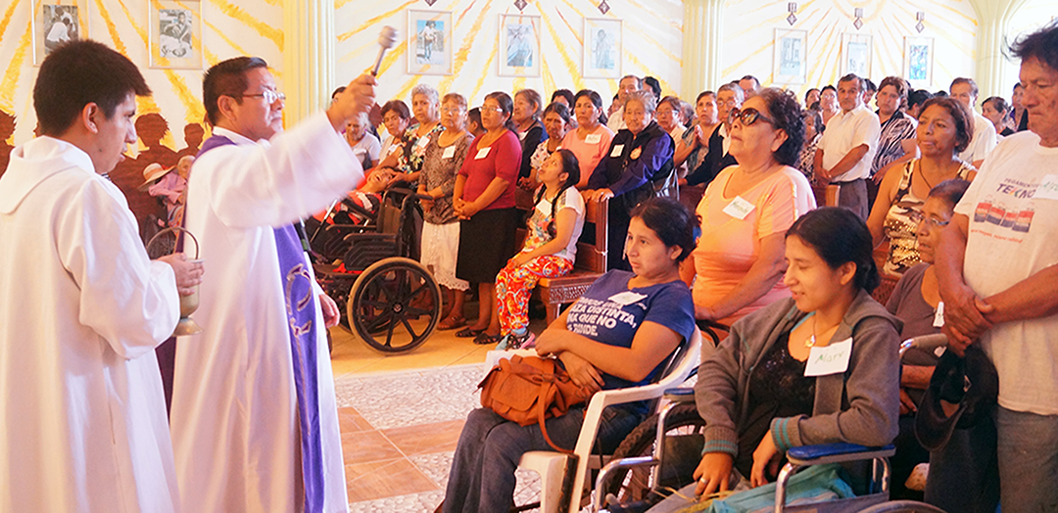

### Faith and Our Lady of Perpetual Help Parish

Friends of Chimbote and ACAF are faith based organizations that welcome visitors and volunteers regardless of their religious affiliation as long as they embrace our core values and service model to empower the poor. And while we are not a Catholic organization; an integral partner in our commitment to meet the spiritual  needs of those we serve in Chimbote is Our Lady of Perpetual Help parish. With 85% of the population within the Diocese of Chimbote being Catholic, the spiritual support and guidance provided by the pastor and parish is critical. Through liturgy, blessed sacraments, faith-formation, choirs, and retreats; Gospel-inspired hope and joy is present within the community.

Mission visitors and volunteers are encouraged to attend and participate in parish activities while in Chimbote. You may be surprised and inspired by the joyful liturgies and other parish centered services that will fill your heart with optimism and peace.

***Carrying out mission programs and services requires the alliance of all three entities working in harmony; Friends of Chimbote, ACAF, and Our Lady of Perpetual Help parish. While each has different responsibilities, challenges, and opportunities, we all are united in a common purpose to serve the poor of Chimbote and transform their lives with compassion, integrity and respect.***

**About Chimbote and Peru**

Peru is located in western South America on the southern Pacific Ocean and is proportionate in size to the state of Alaska. The topography is comprised of 3 very diverse regions; the dry desert of the western coastal plains, the high and rugged Andes mountains and the eastern lowland jungle of the Amazon Basin. It has a population of just under 30 million people with approximately 25% living in its’ capital city of Lima. Peru is divided into 25 regions and while it remains a poor country it is one of the richest in terms of natural resources such as gold, silver and copper. The political structure in Peru is a presidential representative democratic republic. Sadly corruption is a very significant problem in Peru and a great divide remains between the very wealthy and those living in poverty.

**Chimbote** is the largest city in the Ancash region of Peru, and the capital of both the Santa Province and Chimbote District. Home to more than 400,000 people many of whom live in extreme poverty, Chimbote lies approximately 250 miles north of Lima in a coastal desert region.

In 1940, Chimbote was a small fishing port, with a population of 2,400. Following the opening of several fish factories and an iron and steel plant, the village population multiplied more than seventy times boosting the inhabitants to 170,000 by 1970. That same year, with a continued migration of countless families from the mountains seeking employment, a devastating earthquake occurred in Chimbote. 70,000 lives were lost and thousands were left homeless.

Since then the city of Chimbote has slowly been rebuilt but lacks infrastructure.  Overfishing has occurred along with environmental pollution leading to hundreds of fishing boats floating empty in the Chimbote harbor and fish-factories closed or in partial operating mode. This has contributed to an economy in Chimbote that has left thousands of families struggling to survive.

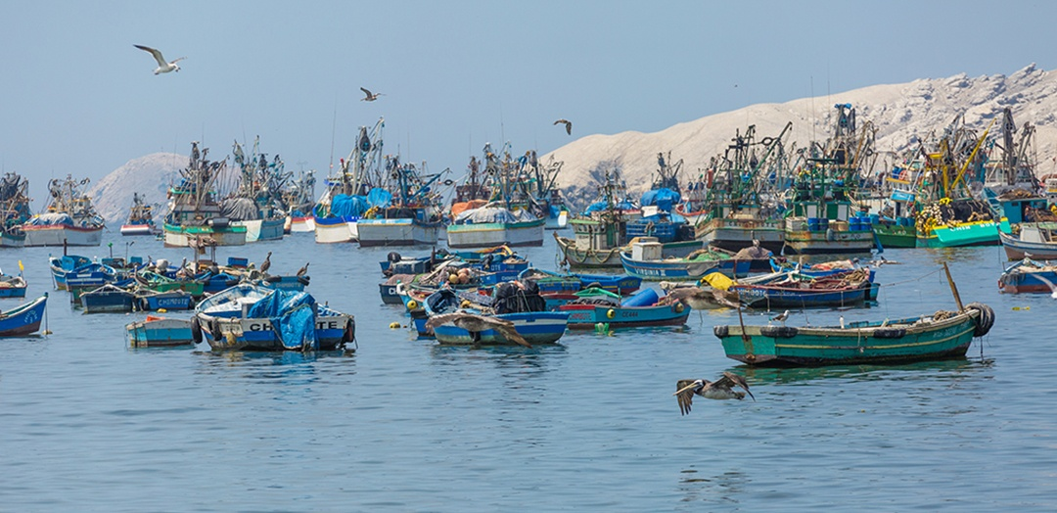

### Things to Know about Peru

* The Nuevo Sol is the official currency of Peru
* International Phone Dialing Code for Peru is + 51
* Electricity in Peru is 230V / 60 Hz
* Mining, fishing and tourism are the top 3 industries
* An estimated 1.5 million people visit the ancient Incan city of Machu Picchu each year
* Peru celebrates its Independence from the Spanish Empire on the 28th and 29th of July

### Interesting Facts about Chimbote

* The city’s first inhabitants were the Recuay, the Inca, the Wari, and the Moche peoples.
* Chimbote was once considered the anchovy capital of the world.
* Fishing remains one of Chimbote’s chief industries, though re-occurring El Nino’s and overfishing caused restrictions to be imposed to ensure its survival.
* Spanish is the official language, with Quechua and Aymrar as secondary languages.
* Annual precipitation is near zero.

**Chimbote’s Climate**

Chimbote is situated in the coastal desert area of Peru and is influenced by arid winds and on-shore fog. The city has two seasons:

Summer: - December – March/April

Winter: April/May – November (cloud cover most days without rain)

Chimbote’s climate is fairly uniform and comfortably warm year-round with an average daily temperature of 69°F/21°C. It gets colder at night so a sweater or jacket is recommended. It is a very dry environment with a high amount of dust and salt in the air. Located close to the equator sunburn can occur easily year around so take care and wear sunscreen.

#### Average Monthly Temperatures for Chimbote, Peru

|  |  |  |  |  |  |  |
| --- | --- | --- | --- | --- | --- | --- |
| **Month** | **°F** | **˚C** |  | **Month** | **°F** | **°C** |
| January | 73.4 | 23.0 |  | July | 65.7 | 18.7 |
| February | 74.8 | 23.8 |  | August | 64.6 | 18.1 |
| March | 74.1 | 22.1 |  | September | 64.8 | 18.2 |
| April | 71.8 | 22.1 |  | October | 66.0 | 18.9 |
| May | 68.9 | 20.5 |  | November | 68.2 | 20.1 |
| June | 67.3 | 19.6 |  | December | 71.2 | 21.8 |

**Our Mission Visit Philosophy**

We understand that it is often the expectation of mission visitors to do as much manual labor as possible while in Chimbote but that is not the priority of our mission visit program. Rather we invite you to observe, listen, and witness poverty and the mission programs and services that are in place to help alleviate it. And if you choose to do project work, know that it is welcome but that it must be done in the spirit of partnership with the local community so that you are “doing-with” rather than “doing-for.”

Based upon the premise that charitable support without active participation from the program recipients will lead to dependence rather than independence we ask all mission visitors to support these principles:

* First – listen to the poor and learn what they have identified as their needs to help themselves overcome poverty. Recognize that your priorities may differ greatly from theirs. Seek first to understand.
* Observe the mission staff members who work with the program recipients every day who know best the needs of the people they serve. Seek their advice before offering help to people you meet to avoid misunderstanding and charity that may inadvertently hinder rather than help.
* Be aware of your own desire to quickly fix situations and instead recognize that sustainable change takes time and dedicated investment from the local community.
* Encourage and welcome participation from the families that you serve. Work side-by-side with the local people and embrace their talents, skills and abilities. Get to know them and their unique situations, dreams, goals and challenges.
* Respect the cultural differences and have an open mind; embrace the many beautiful lessons to be learned from the local people.
* Have fun; play with the children, practice your Spanish and share hugs, tears, and laughter. You will leave the mission with warm memories that will far outweigh the material goods that you arrived with.

In addition we ask that you exercise caution in sharing your personal contact and social media information with people that you meet. Poverty can and does lead to requests for financial assistance and our staff in Chimbote is best equipped to assess and manage the needs of the poor.

**Health and Safety**

**Health**

Robust health is necessary for those who wish to visit our mission. If you have a physical, mental or psychological condition that may inhibit your ability to participate there are many other ways in which you can support the people of Chimbote. Though there are doctors and clinics in Chimbote, they are not comparable to the healthcare available in developed countries.

**Immunizations & Disease Control**

No immunizations are required for travel to Peru; however you should be up-to-date on all routine vaccinations. Note that at the time of this handbook being published there is NOT a history of malaria, yellow fever, Dengue Fever, or Zika Virus in Chimbote, Perú. However you should visit the Center for Disease Control Website/Peru for up-to-date information and recommendations at: <http://wwwnc.cdc.gov/travel/destinations/traveler/none/peru>

**Food and Water Borne Illness**

When you are at the mission as part of a group, our cooks will prepare tasty and safe meals and if you are a long-term volunteer you will stay with a trusted host family. All food prepared and served at the visitor quarters and by host-families is safe to eat. Purified water is provided so be sure to bring a refillable water bottle.

Be aware of the following suggestions to avoid illness throughout your time in Peru:

* Only drink purified water. Avoid getting tap water in your mouth by using purified water to brush your teeth and closing your mouth while showering.
* Stay hydrated by drinking plenty of water. Avoid excess caffeine and alcohol.
* Avoid raw foods that may have been washed in tap water, such as lettuce or berries. Fruit that can be peeled, such as oranges or mangos, are OK. When in doubt, always ask before eating.
* Do **not** buy/eat food from street vendors.
* Before eating, always wash your hands with anti-bacterial gel, anti-bacterial hand wipes, or with soap and water.

**Medication**

Bring all of your usual/prescription medication with you from home in their original bottles and take it as usual while in Peru. It’s a good idea to bring basic medications, such as Tylenol, Advil, allergy medications, and any other medications you think could be necessary. If you are concerned about travel-related stomach ailments ask your doctor for a prescription for a broad spectrum antibiotic such as Cipro that you can bring with you and use if needed.

If you do become ill while at the mission please advise your group leader and our mission visit team members right away. We will do all we can to help you recover and return home in good health.

**Travel Insurance**

Friends of Chimbote highly recommends that all mission visitors and volunteers obtain temporary medical and emergency insurance that can be purchased for the duration of your trip. This type of insurance does not replace your own medical insurance and typically does not cover pre-existing conditions. It is very affordable and the benefits can be significant. Group rates are often available. We suggest that if you choose to obtain travel insurance that you be sure your policy covers accidents and sickness, emergency medical evacuation expense, mortal remains expense, and accidental death and dismemberment benefits.

One agency that specializes in coverage for mission groups and that many past Chimbote mission visitors have used and recommend is:

**Insurance Services of America**

**1757 E. Baseline Road, Suite 126**

**Gilbert, AZ 85233**

**480-821-9052/1-800-647-4589 (480) 821-9297** [**health@missionaryhealth.com**](mailto:health@missionaryhealth.com)

**Safety When Traveling in Peru**

Any foreign travel by nature involves some risk and there is a rising incidence of crime in Peru especially in high tourist areas. On page 12 specific safety advice regarding Chimbote is outlined but **wherever** you choose to travel in Peru be mindful of the following:

* Use only licensed, registered taxis such as those available from taxi stands displaying a decal issued by the municipal government. Always store suitcases in the trunk.
* Keep cash and identification in your front pockets or a money belt or small purse with a strap that goes across your chest.
* If taking an overnight public bus be aware of thieves who may steal your passport, cameras, and other valuables while you are sleeping. Do not store them in an overhead area and instead store under your feet.
* Contact your cell phone company in advance of your travel and request international service if available. Keep your phone charged and on your person for use in emergency. Preload emergency contact numbers.
* Tell friends or family where you are going and give them your travel schedule.
* Contact the US Embassy in Lima if you need assistance, lose your passport or have been the victim of a crime in Peru.

*U.S. Embassy, Avenida La Encalada cdra. 17 s/n, Surco, Lima 33*

*Telephone +(51) (1) 618-2000*

*Emergency After-Hours Telephone +(51) (1) 618-2000*

*Fax +(51) (1) 618-2724*

*Email:*[*LimaACS@state.gov*](mailto:LimaACS@state.gov)

**For additional safety tips visit:** <https://travel.state.gov/content/passports/en/country/peru.html>

**Safety & Security Policies in Chimbote**

Shortly after your arrival in Chimbote, orientation to the visitor quarters and review of our safety and security policies will be provided by our mission visit team members. All mission guests regardless of the number of times they have been to Chimbote will participate in this important process.

* Friends of Chimbote cannot be held responsible for the loss or theft of personal belongings. All visitors muse keep their belongings secure at all times.
* Lockers are provided in the dormitories and padlocks are available.
* Visitors should not carry their passports with them in Chimbote! Lock them up in the lockers provided along with credit cards, cash, etc.
* It is okay to carry a few soles in your day pack as you may need them to buy a soda or pay for a taxi.
* 2 guards will be present at the parish compound; one to monitor the gate and the other to accompany any group members for a short distance.
* A local police officer will be present to further ensure visitor safety.
* Group members will be provided with a key to their assigned dorm as well as the dining room. Keys may not be given to anyone else by a group member and must be returned at the end of the visit.
* Dorms and the dining room shall be locked whenever group members are not present.
* A member of the mission visit team will be available to stay on-site when a group requires or requests it. This will be mandatory for all first time groups/leaders.
* All group leaders will be provided with the volunteer coordinator (VC) cell phone number and must have a working cell phone within Peru so that he/she may call the VC at any time day or night if needed.
* No group member should be out alone; they must always be accompanied by a translator, member of the mission visit team, or other trusted person as assigned by ACAF.
* All group members must be in the parish by 10 pm unless a group or individual activity was previously coordinated/approved with the VC and group leader.
* Group members may not make plans with any locals unless previously coordinated with the VC and group leader.
* When groups are out in the neighborhoods, they shall always be accompanied by trusted ACAF staff (for the tour, projects, etc.)
* Group members will not use any public transportation in Chimbote unless accompanied by a trusted ACAF team member.
* Though the sunshine in Peru may feel very good, always use a high SPF sunscreen to avoid painful and dangerous sunburn. Wear a comfortable hat and long sleeves if you plan to be outdoors for lengthy periods.

**Currency and Money Considerations in Peru**

The full name of the currency in Peru is the Peruvian Nuevo Sol and the abbreviation used on international money exchange charts is PEN. The plural of sol is soles (pronounced SO – lays). The exchange rate varies and is available on many banking and currency websites. One of our favorites is [www.oanda.com](http://www.oanda.com)  where you can view current exchange rates and print out a pocket-size conversion “cheat sheet" or download the app on your smart phone.

It is expected that most of your major expenses in Peru will be pre-paid eliminating the need for large amounts of cash or credit-card use. However you may wish to have some funds available for souvenirs, taxis, meals eaten at restaurants and other incidentals.

**Taxis, Restaurants, and Other Incidental Expenses**

You can plan on taxis, food, and restaurants in Lima to cost about the same as they do in the United States. However, in Chimbote, the costs are generally less. If you invite a Peruvian to join you in a taxi, or for a meal at a restaurant please remember that you are responsible for their bill as well as yours.

**What Kind of Money to Bring**

* **Cash** Small amounts of cash can be brought with you to Peru and exchanged for soles at the Lima airport upon arrival, or at your hotel if they provide the service. There are also small currency exchange shops in Lima as well as local individuals who do so for a living. Always ask your hotel concierge or travel agent to assist you with currency exchange. For security reasons we do not keep large amounts of soles on hand at the mission for visitor exchange and prefer that you use ATM machines or exchange your funds prior to arrival in Chimbote. Be aware that only bills in new/excellent condition will be accepted for exchange. Avoid bringing bills from home with tears, creases or holes.
* **Credit or Debit Cards** Credit and debit cards are widely accepted in Peru and standard ATM machines are widely available including in Chimbote. Be sure to contact your bank or Credit Card Company before you leave and know your PIN if you plan to use an ATM. You can get soles from the ATM’s in Peru eliminating the need to exchange money.
* **Checks** Do not bring checks of any kind to Peru including Traveler checks. They are difficult if not impossible to use.

Everyone is responsible for the security of his or her own funds so discretion is recommended. Keep your money and credit cards in a secure location at all times and use caution in highly-populated areas. Pick-pockets are common in Peru but can be avoided with proper precautions.

**Planning Your Trip**

**The Mission Visit Toolkit** located on our website includes the application forms for mission groups as well as individuals who wish to volunteer, along with group leader forms and checklists.

**Things to know about group visits**

* Groups ranging in size from 2 up to 25 people can be accommodated at the mission.
* Once you have decided that you want to travel to Chimbote for a group visit contact the Friends of Chimbote office located in Fargo, ND (701) 364-0162 to begin the application process. You can review requested dates and see if they are open and ask any questions.
* Note that the recommended stay for a group in Chimbote is 6 nights with groups typically arriving in Chimbote on a Sunday and departing on a Saturday.
* Group leaders will work closely with our mission visit team and must be a minimum of 21 years of age.
* We recommend that group members be at least 14 years of age. Any group member under 18 years of age must be accompanied by a parent or an assigned guardian who is at least 21 years of age.
* Applications are accepted up to 12 months before your requested mission visit date and we recommend you submit your application at least 6 months in advance.

**Things to know about our long-term volunteer program**

* If you wish to volunteer at the mission complete our Volunteer Application found in the Mission Visit Toolkit on our website.
* A minimum 6 week commitment is required, along with varying levels of Spanish skills depending upon what volunteer position you will be asked to fill.
* Volunteers must arrive in Chimbote for orientation either the 1st or the 15th of a month.
* Once accepted into the program, the volunteer coordinator in Chimbote will assist you in planning your volunteer experience.

**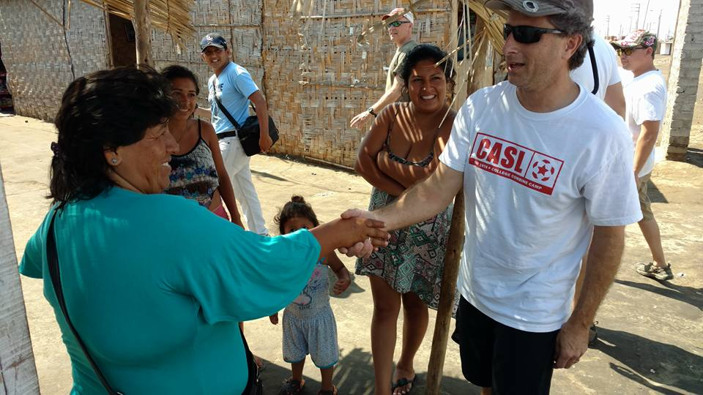**

**Accommodations, Schedule, Internet & Phone**

We are committed to making your time at the mission as comfortable, informational, and as meaningful as possible.

**Typical Schedule**

All groups will plan the majority of their projects and activities in advance with our mission visit team and while all groups are unique, a typical mission visit schedule is as follows:

**Day 1 – Saturday** Travel from your home country to Peru. Overnight in Lima.

**Day 2 – Sunday** Travel from Lima to Chimbote. Get settled in dorms. Welcome dinner, orientation to visitor quarters and safety & security plan review.

**Day 3 – Monday** Orientation and Tour of Mission Programs, then group projects and activities.

**Day 4 – 7 Tuesday - Friday** Projects and Activities at the mission.

**Day 8 Saturday** Return to Lima for overnight flight back to US or begin side trip.

**Accommodations and Internet & Phone Service**

Our visitor quarters are located within the guarded mission compound of Our Lady of Perpetual Help parish. We offer spacious dormitory-style rooms with comfortable beds, bathrooms and warm showers. We provide pillows, sheets and blankets but ask that you bring your own hand towel, washcloth and bath towel that can be donated upon your departure.

You’ll spend time in the dining room – often referred to as the “gringo room” where we have a large dining space, bottled water dispensers and a lounge area. Be sure to check out the view from our rooftop; this is also a great place to share group reflections at the end of each day. Long-term volunteers stay with trusted host families living in the neighborhoods served by the mission.

Limited Wi-Fi is available at the mission but is often slow so please be patient. And while we understand the need to stay in touch with home we ask you to limit your screen time so that you may be in-the-moment and take advantage of your time in Chimbote to the greatest extent possible. Most cell phones work in Peru but check with your carrier for international service before you leave. A land line phone is available for brief and/or emergency calls.

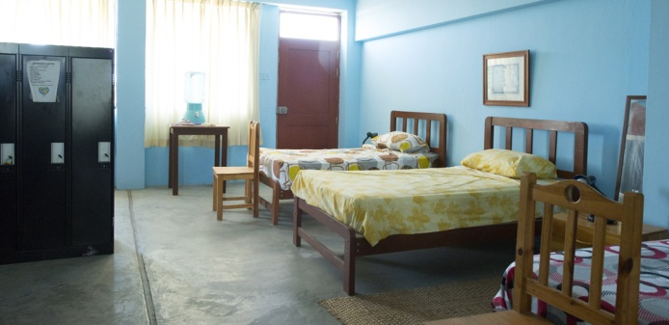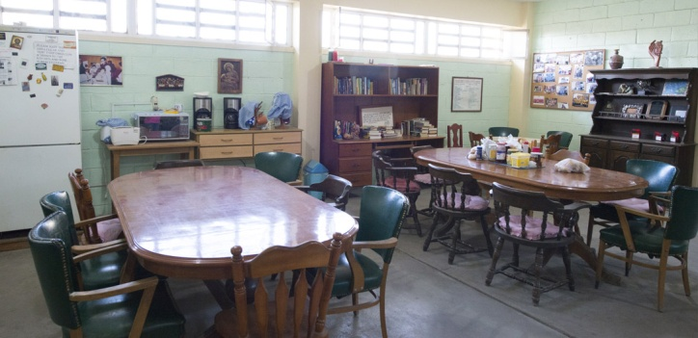

**Projects and Activities**

First and foremost it is our goal that you will witness and learn about poverty and the mission programs and services in place to help alleviate it. We encourage you to get to know the local people; not only the mission staff but the people living in poverty whose homes you will visit, and who you will provide help and assistance to. This serves several purposes:

* **An opportunity to see firsthand all that is occurring.** You may be surprised by what you see and hear and leave with a deeper understanding of the needs of the people of Chimbote that’s easy to miss if the entire visit is spent on a specific project.
* **An opportunity to experience the deep hospitality that is part of the Peruvian culture.** In a sense, you’ve already given a gift by leaving your comfortable life to come to Chimbote. By taking time to get to know the people—to experience their hospitality and friendship—you allow the people of Chimbote a chance to give back.
* **A chance to absorb the mission experiences more fully, and be a mission advocate when you return home.** When you return to your community you will be a resource to others on what is happening in Chimbote. Your first-hand knowledge will be appreciated and respected and you can inspire others to visit and support the mission.

**Orientation and Tour**

Within the first day or two of your mission visit you will be presented with an overview of mission programs and services and an in-depth tour of our programs and facilities. Bring comfortable walking shoes so that you can fully participate. We offer a van for those who are unable to walk distances. As part of the tour you will visit the barrios where the poor reside and what you see may be shocking and upsetting. Allow yourself time to adjust to the environment and process what you’re seeing.

**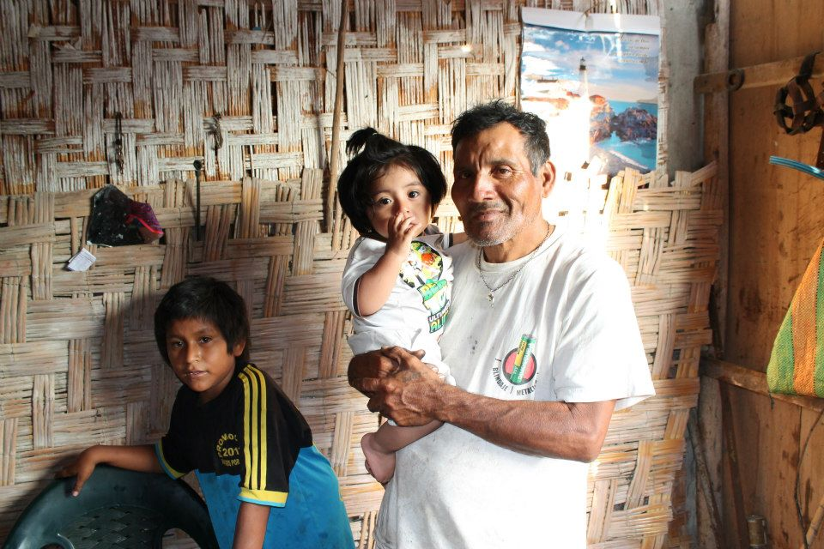**

**Description and Costs of Typical Projects and Activities**

Your mission visit experience may include a number of opportunities and activities. Some such as assisting the mission staff in the daycare centers or soup kitchens or visiting homes with our social workers do not require fundraising, just an open mind and a willing heart.

Others like repairing or constructing homes or taking families on outings–will require fundraising on your part prior to your visit. Each group will work with our mission visit team in advance of their visit to decide what will work best and current costs will be provided. Payment is made to Friends of Chimbote at least 30 days in advance so that necessary supplies and plans are in place upon your group’s arrival in Chimbote.

* **Home Construction & Household Goods**

There is an on-going need for adequate shelter and household goods amongst the people that our mission serves. Your funds will allow you to work side-by-side with the local people to reconstruct and update homes and deliver furniture and supplies.

**$2500** Remodel an entire home for a family including an eternit roof that will provide protection from the elements for years to come.

**$1200** Replace estera walls in a 3-bedroom home.

**$700** Build a new eternit roof on an estera home.

**$80** Provide a gas stove and tank for a family

**$300** Deliver a houseful of furniture for a family in need including a bed, stove, small and large table, 4 chairs and a dresser.

**$140** Provide a double bed including linens, blankets and pillows for children who all too often sleep on dirt floors or share a bed with their parents.

* **Suggested Activities**

The opportunity to visit the beach, play games, or eat a beef dinner is out of reach for most of the families that our mission serves. Hosting an activity is a wonderful way to mingle with the local people and provide joyful memories for all.

**$700** Hold a carnival for the children living in the poorest barrios with games, prizes and snacks.

**$500** Buy a cow and host and serve a delicious meal for poor families. A local band with singing and dancing will complete this fun event.

**$500** Take a group of handicapped people and their caregivers to the beach for the day and serve them a nice meal and play games.

**$250** Host a birthday party for the Golden-Agers group, don part hats, serve cake and dance!

**Don’t see the project or activity you had in mind? We welcome suggestions so let your mission visit team know and we will help you decide if it is possible.**

**Travel Arrangements & Costs**

Mission groups and volunteers are responsible for making their own travel arrangements from their country of origin to Peru, and from Lima to Chimbote. Once you arrive in Chimbote all arrangements including transportation, meals, accommodations and activities and projects are handled by our mission visit team.

Contact our office 701-364-0162 if you would like a current list of recommended travel agents noting that Friends of Chimbote cannot be responsible for any problems or issues that may be a result of your interactions and arrangements with any travel agent or company.

**There are typically three categories of expenses associated with a mission tip to Chimbote:**

1. Transportation and Hotels that includes round-trip travel from your country of origin to Peru, hotels and transfers in Lima, and round-trip travel from Lima to Chimbote. **These costs are paid direct to your travel agent, airline, hotel, and/or bus-company.**
2. Fees and expenses while at the mission including room and board and projects and activities. **These costs are paid to Friends of Chimbote in advance of your trip.**
3. Side trip costs (if applicable.) **Paid direct to your travel agent/company.**

**1. Transportation & Hotels**

**Flights from U.S. to Lima, Visas, Immigration, and Customs** All international flights into the country of Peru must fly into [Jorge Chávez International Airport](https://www.google.com/url?sa=t&rct=j&q=&esrc=s&source=web&cd=3&cad=rja&uact=8&ved=0ahUKEwi69Mvn6bHMAhUBTGMKHTV_AW8QFggwMAI&url=https%3A%2F%2Fen.wikipedia.org%2Fwiki%2FJorge_Ch%25C3%25A1vez_International_Airport&usg=AFQjCNHLLctNzUNajxb4lxUUY7BrQjbcBw)  in Lima. Most major US airlines fly to Peru. Flights to Lima typically take 8 hours from New York City, 7 hours from Houston or Atlanta, and 6 hours from Miami. Check with your airline of choice or your travel agent for current airfare costs for the dates that you will be traveling.

While still on the plane, you will receive 2 forms; the first is a two-part form to fill out that will act as your temporary visa while in Peru. When you pass through immigration, your passport will be stamped and you will get one section of the visa form back. **Do not lose the form. Keep it with your passport as you will need it when you leave Peru.** If you lose it a significant fine will be charged. The other form is for customs that you must complete and give to the customs agent before you leave the secure area of the airport. Typically all of your luggage must be scanned and at times your luggage may be hand-screened by customs personnel who may wish to confiscate or charge a fee if they find items that are not allowed. These can include things like new electronic items still in the box, or large amounts of medications.

When you leave customs you will enter the waiting area of the airport and the scene will be crowded and chaotic. We strongly advise that you have arranged for a mission representative and at the very least a travel agent to meet you at the airport. They will typically hold a sign with you or your group’s name on it. If for some reason there is no one to meet you (whether by your choice or an unforeseen complications), you can take a taxi to the hotel. Be sure to have your hotel name, phone number and address with you. Use only licensed, registered taxis such as those available from taxi stands displaying a decal issued by the municipal government. Always store suitcases in the trunk. Agree on the price before you enter the taxi.

**Hotels in Lima**

Because most flights arrive in Lima late in the evening most mission visitors typically spend their arrival night in Lima. There are many websites that list hotels in Lima, including [www.go2peru.com](http://www.go2peru.com" \t "_blank). We recommend that your travel agent book transfers from the Lima airport to your hotel and make hotel reservations for you. The Mira Flores or Barranco districts are among the most popular and tourist-friendly areas for visitors to stay. Average nightly rates for a moderate hotel are $50 - $75.

**Travel from Lima to Chimbote**

It is not possible to fly from Lima to Chimbote. Chimbote is located north of Lima and south of a large northern city called Trujillo (troo – HEE – oh). Most visitors arrive in Chimbote by one of two routes:

* + Lima to Chimbote by either private bus (recommended for large groups that your travel agent will book for you) or by public bus lines such as Cruz del Sur that offer comfortable and safe motor-coach accommodations. The average bus ride from Lima to Chimbote is 6-8 hours and the average cost on a public bus-line is $60 round trip.
  + If you prefer to fly to Trujillo and then take a 2 hour bus ride to Chimbote work with your travel agent to book your flights on airlines such as LAN. The flight is less than one hour and the average round trip cost is $300.

**2. Fees and Expenses at the Mission**

A daily rate of $20 per person is charged for room and board for groups at the mission. This is due a minimum of 6 weeks prior to your arrival date and an invoice will be issued to the group leader. See group projects and activity fees or other costs. If you are a volunteer staying with a host family, refer to the volunteer application for current costs.

**3. Side Trips**

Peru offers many beautiful destinations for side trips either before or after your mission visit. From the ancient Incan ruins of Machu Picchu to the Amazon rainforest, we highly recommend you explore all that Peru has to offer. Contact your travel agent for trip options and costs noting that high season is June-August so you will want to book as early as possible.

**What to Bring**

**This checklist has been compiled in collaboration with past mission visitors and includes the things that will make your journey and visit both enjoyable and safe.**

* Passport (And make sure to leave a copy of passport at home and pack a copy of your passport in a separate place from your original passport.)
* A journal to document your thoughts, feelings and impressions.
* Airline or e-ticket number.
* Credit and/or debit card – to use in ATM’s. Be sure to know your PIN number & contact your bank in advance to alert them of your travel plans.
* Secure place to keep your documents, money and credit/debit cards when traveling -- such as a money belt.
* Personal toiletries such as antibacterial hand gel, hand soap, Tylenol or Advil, Imodium, sunscreen, shampoo and conditioner.
* Washcloths, a hand towel, and a bath towel.
* Easy to use English-Spanish dictionary.
* Pictures of where you live, your family, your pets, etc. (the people love to look at them)
* 3 to 2 prong electrical prong for any 3 prong items you may have as well.
* An electrical converter if you have any items such as shavers, hair dryers, computers or phones that do not already have a built-in converter.
* Re-useable water bottle.
* Small Padlock – to lock up your valuables in lockers provided at the mission.
* Camera or smart phone for taking photos.
* Small flashlight/batteries since the electricity can go out frequently.
* Energy bars/small snack items for during the day.
* Snacks to share such as microwave popcorn, nuts, snack mix, or candy.
* Peanut butter! Very expensive in Peru so bring a jar to share.
* Coffee drinkers may wish to bring ground coffee suitable for a drip coffee maker. Due to the high cost of coffee in Peru, only instant coffee (Nescafe) is provided.
* Back pack or "day pack"
* Casual, modest, seasonally and culturally appropriate clothing. (See “cultural norms.”)
* Suggested clothing/attire includes comfortable walking and work shoes, flip-flops for showering, bandana, T-shirts, Hat, comfortable pants, casual outfit for public outings, light jacket, heavy jacket (August – October), long sleeve shirt/sweatshirt, and sunglasses.
* Ziploc bag with laundry detergent if you want your laundry done while at the mission.
* Work Gloves, face mask, & pliers if project work planned.

**Suggested Donations to Bring With You**

If space allows it is always meaningful to bring items with you that in cooperation with our mission staff; you can gift to the local people. But before you begin packing check with your airline on luggage restrictions since fees for excess luggage can be costly. The same applies to public bus companies in Peru as well as domestic airlines. Ask your travel agent for current information.

**Home in a Bag**

Mission social workers have identified numerous families that would benefit from a bag filled with household goods. You will have the opportunity to personally deliver your gift bag to a family living in the mission barrios and share their joy as they delight in the items that you gift to them. Following is a list of suggested items for the gift bag. It will only weigh approximately 9 lbs. and can be carried-on or packed in a checked bag. The approximate cost = 0 - $75.00 depending upon where you get the items…..used items are okay as long as they are in excellent condition.

**Pack these items in either a Reusable Shopping Bag *or* a lightweight backpack**

1 Bath towel (dark colors preferred)

2 Wash Cloths (dark colors preferred)

4 Containers with lids (Gladware or similar. Small to medium size)

4 Melamine or other non-breakable plates (medium size)

4 Plastic glasses (stackable-juice/or short size)

1 Melamine **shallow** serving bowl (medium size)

2 Flour-sack dishcloths

1 Notebook

4 Pens

1 Box of band-aids (fun, colorful)

1 Roll of duct tape

1 Bag of candy for the kids

2 Small toys for children (little balls, crayons, figures, dolls, etc.)

1 Brush

1 Set of combs

1 Set of hair bands for the women and little girls to use.

1 Teddy Bear or other small stuffed animal who would like to live in Peru!

**This list is can be varied if you have something special you would like to include or can’t find a particular item.** For easier packing, fit things inside of each other, i.e. roll the washcloths and stick them inside the top of the stacked glasses. Place items in the serving bowl before sliding it into the bag. It will also help when purchasing to buy things without a lot of packaging or remove the packaging before placing in the bag.

**Other Suggested Donations**

If you prefer not to pack an entire home gift bag you may bring any of the items listed below. Mission visitors will work closely with mission staff on who, when and where to distribute the donated items:

* Combs and brushes, hair bands, clips and ties
* Toothpaste and toothbrushes
* Soap and shampoo (not conditioner)
* Reading glasses and sunglasses – modern frames
* Lice and scabies medication – must not be expired
* Powdered formula for babies, must not be expired
* Socks of all sizes
* Caps/hats –baseball-style
* Duct tape
* Post-it notes
* Dictionaries with Spanish-to-English translations
* Coloring books in Spanish
* Coloring pencils or markers (not crayons)
* Pens, pencils, notebooks and legal pads
* Glue, especially paper glue in stick form
* Soccer Balls (deflated) and hand pump to re-inflate
* Reusable Shopping Bags or lightweight backpacks
* Bath towel and washcloths (dark colors preferred)
* Containers with lids (Gladware or similar. Small to medium size)
* Melamine or other non-breakable plates (medium size)
* Plastic glasses (stackable-juice/or short size)
* Flour-sack dishcloths
* Box of band-aids (fun, colorful)
* Roll of duct tape, small tools, work gloves, face masks
* Bags of candy for the kids – avoid candy that could melt
* Small toys for children (little balls, crayons, figures, dolls, etc.)
* Teddy Bears or other small stuffed animals.
* Books or calendars with large colorful pictures. (Okay of expired, just need/like pictures to put up on walls.)
* New or gently used infant and children clothing
* New or gently used women’s or men’s clothing – prefer XS, S, or Medium

Things **NOT** to bring: Athletic shoes, electronic items or anything requiring batteries, any clothing that is torn, stained, missing buttons or snaps, or any clothing larger than adult size large.

**Cultural Norms in Chimbote**

One of the best ways to have a rewarding experience in other countries is to respect the culture there. Because of the extreme poverty in Chimbote, that means respecting both long-time Peruvian cultural traditions as well as norms that have developed due to the extreme poverty in the area. The following list of “do’s and don’ts,” will help you meet both of these goals.

**DO:**

* **Remember that you are our guest and as such you are an ambassador for Friends of Chimbote.** Be polite, interested, caring, and observant.
* **Expect to be greeted like the Peruvians do.** Even if you are a stranger the usual method of greeting and saying goodbye is to kiss the left cheek. It is also typical to kiss one another's cheek during Mass during the sign of peace. If you are uncomfortable with this – extend your hand to shake instead and always do so with a smile.
* **Dress modestly.** This means avoiding tiny, tight, or midriff baring tops, short shorts and short skirts. For men, avoid going bare-chested. Everyday dress in Chimbote is casual – jeans, khakis, shorts, t-shirts, or collared shirts. *If we view inappropriate clothing by any mission visitor we will ask and expect you to change into something more appropriate and acceptable.*
* **Practice patience.** Americans are accustomed to a fast pace and expect efficiency and speed. In Peru, patience is key and flexibility is a must. Events may or may not occur on time.
* **Try using some Spanish.** Peruvians are delighted when you show interest in learning the language, even if your attempts are less than perfect!
* **Try to keep your own questions and needs to a minimum and save them for group sharing and reflection time.** It’s important to remember that all the comforts of home are not possible at the mission and instead learn from and embrace the opportunity to live more simply.
* **Observe our alcohol and tobacco policy.** We believe in healthy life-style modeling and expect mission visitors to set a good example for the local people where alcoholism is a major issue and has led to numerous and often violent acts in many families. Alcohol may only be consumed within the private visitor quarters by those 21 years of age or older and in moderation. Smoking is not allowed anywhere other than in designated areas of the visitor quarters. Smoking in or near estera homes is a fire hazard and is not acceptable. Illegal drugs are strictly forbidden.
* **Clean up the eating and sleeping areas regularly**. Let us all remember that we are not in Chimbote to be served, but to serve. With that understanding, we will always clean up after ourselves at all times, particularly while within the visitor quarters.
* **Offer to help with dishes**, both with washing and drying the dishes and putting them away in the dining room.

**DON’T:**

* **Hand out gifts, candy, or other items.** It is very tempting to want to hand out candy or toys to the people, especially the children. In fact, many will ask you for candy or other items. Because of the extreme poverty in the area, this activity can quickly cause a "mob effect" if you are not careful. Also, it encourages the locals to ask for things from you instead of having conversations with you, so you will miss the chance to get to know them as people. The mission staff work hard to make sure that charity is provided to only those who really need it, instead of those who aren’t shy about asking for it.
* **Walk alone**. Poverty can and does lead to violence. Always ask a guard or mission visit team member to accompany you outside of the visitor quarters and parish compound even during daylight hours.
* **Enter a private home without first asking permission.** Typical families living in mission barrios welcome mission visitors but always ask first by saying “con permiso?”
* **Take photos of the people without permission.** The children usually love having their photo taken and like to see the photo on your screen after you take it. However adults are more reserved so always ask “foto por favor?” before taking their picture.
* **Wear or display expensive things**. To avoid drawing attention to yourself, do not wear items such as nice sunglasses or expensive watches or other jewelry while in public. Keep cameras, cell phones and video cameras tucked away when not in use.
* **Be alarmed at the noises at night**. At night you may hear many loud noises, bangs, whistles, etc. Do not be alarmed as these are normal and usual sounds in Chimbote. Fireworks are frequent in Chimbote and may sound like gunshots.
* **Promise to send money or give your clothing or shoes to anyone who asks you for it**. Always direct any requests to mission staff who know best the needs of the local people.
* **Approach stray animals.** There are many stray dogs and cats in Chimbote. Use the same good sense you would at home and do not approach any animals unless the owner is present and tells you that it is okay.

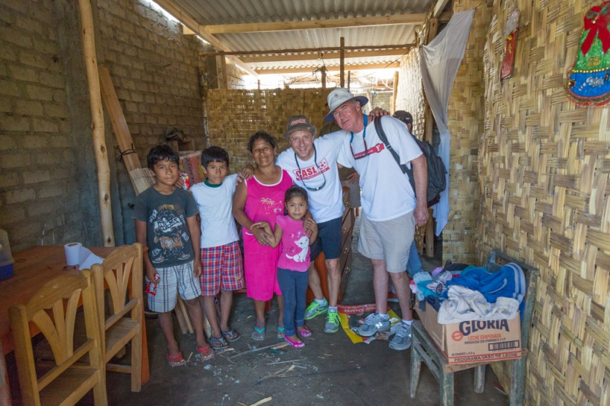

**Helpful Phrases in Spanish**

The most frequent advice from mission visitors is to learn and use more Spanish when in Chimbote. Here are some typical words in English and Spanish to get you started!

|  |  |
| --- | --- |
| Yes/no | Si/no |
| Hello/goodbye | Hola/adiós |
| Good morning | Buenos dias (used until noon) |
| Good afternoon | Buenas tardes (until sunset) |
| Good night | Buenas noches (after dark) |
| How are you? | ¿Cómo está? |
| I'm fine, thanks | Estoy bien, gracias. |
| Excuse me | Con permiso |
| Please | Por favor |
| Thank you | Gracias |
| You're welcome | De nada |
| Where is (are)...? | ¿Dónde está(n)...? |
| What's your name? | ¿Cómo se llama? |
| My name is... | Me llamo... |
| I don't speak Spanish | No hablo español |
| I don't understand | No entiendo |
| How do you say... | ¿Cómo se dice...? |
| More slowly | Más despacio |
| I don't know | No sé |
| Bathroom | Baño |
| Open | Abierto |
| Closed | Cerrado |
| Yesterday | Ayer |
| Today | Hoy |
| Tomorrow | Mañana |
| How much is it? | ¿Cuánto es? |
| Breakfast | Desayuno |
| Lunch | Almuerzo |
| Dinner | Cena |
| Bill/check | Cuenta |

**Contact Information for Friends of Chimbote and the Mission**

If friends or family need to reach you in an emergency when you are visiting the mission they should call the Friends of Chimbote office in the United States and we will assist them in contacting you. If they are not successful in reaching US staff and it is a matter of great urgency they may call Chimbote.

**United States Contact Info:**

**Friends of Chimbote**

PO Box 717, West Fargo, ND 58078

[support@friendsofchimbote.org](mailto:support@friendsofchimbote.org)

Office (Mon – Fri 8 to 5) 701-364-0162

**Peru Contact info:**

**Mission Visit Coordinator in Peru**

[vc@friendsofchimbote.org](mailto:vc@friendsofchimbote.org)

To call from the US: 011-51-943-95-1715

**Mission Visit Quarters in Chimbote**

Parroquia Nuestra Señora del Perpetua Soccoro

Jr. Porvenir S/N - La Victoria

Chimbote, Peru

To call from the US: 011-51-43-32-3375

**ACAF (our non-profit partner in Chimbote)**

Jr Salaverry Mz. Z Lt. 15 – La Victoria

Chimbote, Peru

To call from the US: 011-51-43-32-1413

***Please do not mail letters or packages to Chimbote as the postal system is highly unreliable.***